Umrah Ease
Smart Travel & Booking System

Semester Project — 6th Semester
Session 2023–2027

A project submitted in partial fulfillment of the Subject
Mobile Application Development

Field | Details
Student Name | M. Hammas
Roll No. | SU92-BSSEM-F23-051
Supervisor | Sir Ahmed
Department | Software Engineering
Type | Development Project

Department of Software Engineering
Faculty of Computer Science & Information Technology
Superior University, Lahore
Spring 2026

Project Information
Type (Nature of Project) | Area of Specialization | Project Title
✓ Development | Mobile Application Development | Umrah Ease – Smart Travel & Booking System

Sr.# | Roll No. | Student Name | Email
1 | 051 | Muhammad Hammas | hafizhammas0313@gmail.com

GitHub Link:
https://github.com/Hammas004/umrah_ease

Plagiarism Free Certificate
This is to certify that I, M. Hammas, student at the Department of Software Engineering, Superior University, Lahore, bearing Registration No. 051, declare that the project report titled "Umrah Ease – Smart Travel & Booking System" is my own work. Everything I have taken from other sources has been properly referenced. This report has been checked by my supervisor, Sir Ahmed.

I also confirm that this work has not been submitted at any other institution.

Student Signature: Date: 20-04-2026

Dedication

This work is dedicated to my parents.
Their prayers, support, and trust in me have always meant everything. Throughout this journey, they stood by me in every situation, especially when things got difficult. Their encouragement gave me the strength to stay focused and complete this project. I truly wouldn’t have been able to do this without them.
I also dedicate this work to my supervisor, Sir Ahmed.
He supported me throughout this project and guided me whenever I needed help. Whether it was solving technical issues or improving my work, his advice always helped me move in the right direction. His patience and support made a big difference in completing this project successfully.

Acknowledgements
All praise is to Allah (SWT) for giving me the strength and ability to complete this project.

I want to thank my supervisor, Sir Ahmed, for his constant guidance and support throughout this project. Whenever I got stuck — whether on Flutter navigation, Firebase setup, or anything else — he helped me figure it out. His patience and advice made a real difference.

I am also grateful to the Department of Software Engineering at Superior University, Lahore. The Mobile Application Development course gave me the foundation I needed to actually build this app.

A big thank you to my parents and family for always being there. Their moral support meant a lot, especially during the difficult parts of development.

I also want to mention my classmates who helped with ideas and discussions, and the Flutter and Firebase open-source communities whose documentation made development much easier.

Executive Summary
Umrah Ease is a mobile app built using Flutter and Firebase. It is designed to help Muslims plan and perform their Umrah more easily. The main idea behind the project was that most existing apps are either focused on bookings only, or rituals only. There was no single app that covered everything from hotel booking to step-by-step ritual guidance. Umrah Ease tries to fill that gap.

The app is targeted at three types of users: first-time pilgrims who need detailed guidance, experienced pilgrims who mainly want booking and planning tools, and administrators who manage hotel listings. The app has four main tabs — Home, Permits, Services, and Profile — and a separate Admin Panel.

The main features of Umrah Ease include a step-by-step Tawaf and Sa'i guide with Arabic text and transliteration, hotel booking with real-time Firebase data, a digital permit wallet, an education hub, a packing checklist, a family safety tracker, and an emergency assistance screen with SOS and hotline access.

On the technical side, the app uses Flutter for the UI, Riverpod for state management, GoRouter for navigation with login guards, Firebase Authentication and Cloud Firestore for backend, and SQLite for offline storage. The dark-themed design with a gold colour scheme gives it a clean and premium look.

Testing was done at multiple levels including unit tests, integration tests, and performance tests to make sure the app works correctly. This report covers everything from the requirements and design to the implementation, testing, and future plans.

Table of Contents
Project Information 2
GitHub Link: 2
Plagiarism Free Certificate 3
Dedication 4
Acknowledgements 5
Executive Summary 6
Table of Contents 7
List Of Tables 11
List Of Figures 12
Chapter 1 Introduction 13
1.1 Background 13
1.2 Motivation and Challenges 13
1.3 Goals and Objectives 14
1.4 Literature Review / Existing Solutions 14
1.5 Gap Analysis 15
1.6 Proposed Solution 15
1.7 Project Plan 15
1.7.1 Work Breakdown Structure 15
1.7.2 Roles & Responsibility Matrix 16
1.7.3 Gantt Chart 16
1.8 Report Outline 16
Chapter 2 Software Requirement Specifications 17
2.1 Introduction 17
2.1.1 Purpose 17
2.1.2 Document Conventions 17
2.1.3 Intended Audience 17
2.1.4 Product Scope 17
2.1.5 References 17
2.2 Overall Description 17
2.2.1 Product Perspective 17
2.2.2 Product Functions 17
2.2.3 User Classes 18
2.2.4 Operating Environment 18
2.2.5 Design and Implementation Constraints 18
2.2.6 User Documentation 18
2.2.7 Assumptions and Dependencies 18
2.3 External Interface Requirements 19
2.3.1 User Interfaces 19
2.3.2 Hardware Interfaces 20
2.3.3 Software Interfaces 20
2.3.4 Communications Interfaces 20
2.4 System Features 21
2.4.1 Feature 1 — User Authentication 21
2.4.2 Feature 2 — Live Ritual Guide 22
2.4.3 Feature 3 — Hotel Booking 24
2.4.4 Feature 4 — Digital Permit Wallet 25
2.4.5 Feature 5 — Emergency Assistance 25
2.5 Non-Functional Requirements 26
2.5.1 Performance 26
2.5.2 Safety 27
2.5.3 Security 27
2.5.4 Software Quality Attributes 27
2.5.5 Business Rules 27
2.6 Other Requirements 27
Chapter 3 Use Case Analysis 28
3.1 Use Case Model 28
3.2 Use Case Descriptions 29
UC-01: User Registration 29
UC-02: View Ritual Guide 29
UC-03: Book Hotel 30
UC-04: Admin Manage Hotels 30
Chapter 4 System Design 31
4.1 Architecture Diagram 31
4.2 Domain Model 31
4.3 Entity Relationship Diagram with Data Dictionary 32
4.4 Class Diagram 33
4.5 Sequence / Collaboration Diagram 34
4.6 Operation Contracts 35
4.7 Activity Diagram 35
4.8 State Transition Diagram 36
4.9 Components 36
4.10 Deployment 36
Chapter 5 Implementation 37
5.1 Important Flow Control / Pseudo Codes 37
5.1.1 GoRouter Authentication Redirect Logic 37
5.1.2 Ritual Guide State Logic 37
5.2 Components, Libraries, and Web Services 38
5.3 Deployment Environment 38
5.4 Tools and Techniques 38
5.5 Best Practices / Coding Standards 39
5.6 Version Control 39
5.7 Source Code of Main Screens 39
5.7.1 Sign In Screen (sign_in_screen.dart) 39
5.7.2 Home Screen (home_screen.dart) 42
5.7.3 Ritual Guide Provider (ritual_provider.dart) 45
5.7.4 Emergency Screen (emergency_screen.dart) 48
5.7.5 Admin Dashboard Screen (admin_dashboard_screen.dart) 50
5.7.6 Other Key Screens — Screenshots 54
Chapter 6 Testing and Evaluation 59
6.1 Use Case Testing 59
6.2 Equivalence Partitioning 59
6.3 Boundary Value Analysis 60
6.4 Data Flow Testing 60
6.5 Unit Testing 60
6.6 Integration Testing 61
6.7 Performance Testing 61
6.8 Stress Testing 61
Chapter 7 Summary, Conclusion and Future Enhancements 62
7.1 Project Summary 62
7.2 Achievements and Improvements 62
7.3 Critical Review 62
7.4 Lessons Learnt 63
7.5 Future Enhancements 63
Appendix A: User Manual 64
A.1 Getting Started 64
A.2 Creating an Account 65
A.3 Home Dashboard 65
A.4 Ritual Guide 65
A.5 Services 65
A.6 Permits 65
A.7 Emergency 65
A.8 Profile 65
Appendix B: Administrator Manual 66
B.1 Accessing the Admin Panel 66
B.2 Adding a Hotel 66
B.3 Editing or Deleting a Hotel 67
B.4 Tips for Admins 67
Appendix C: Information / Promotional Material 68
C.1 App Overview 68
References and Bibliography 69

List Of Tables

Table 1 Literature Review 14
Table 2 WBS 15
Table 3 ROLES 16
Table 4 Gantt Chart 16
Table 5 User Classes 18
Table 6 Software Interface 20
Table 7 Attributes 27
Table 8 User Registration 29
Table 9 Ritual Guide 29
Table 10 Book Hotel 30
Table 11 Admin 30
Table 12 Entity Table 32
Table 13 Operation Contracts 35
Table 14 Transition 36
Table 15 Deployement 36
Table 16 Components 38
Table 17 Deployment Environment 38
Table 18 UseCase Testing 59
Table 19 Validation 59
Table 20 Boundry Values 60
Table 21 Unit Testing 60
Table 22 Integration Testing 61
Table 23 Performance Testing 61
Table 24 Future Enhancements 63

List Of Figures
Figure 1 Home Dashboard 19
Figure 2 Preparation Section 20
Figure 3 Onboarding Screen 21
Figure 4 Login Screen 22
Figure 5 Sign Up Screen 22
Figure 6 Ritual Guide_Niyyah 23
Figure 7 Ritual Guide Ihram Step 23
Figure 8 Ritual guide Tawaf 24
Figure 9 Hotel List 24
Figure 10 Permit 25
Figure 11 Emergency Assistance 26
Figure 12 Hospitals 26
Figure 13 Use Case Diagram 28
Figure 14 System Architecture 31
Figure 15 Class Diagram 33
Figure 16 Sequence Diagram 34
Figure 17 Activity Diagram 35
Figure 18 Sign In Screen 41
Figure 19 Home Screen Output 45
Figure 20 Ritual screen Output 47
Figure 21 Umrah Completed 48
Figure 22 Emergency Screen Output 50
Figure 23 Admin Dashboard Output 53
Figure 24 Add hotel Screen 54
Figure 25 Plan Your Stay 55
Figure 26 Select Transportation 55
Figure 27 Sa'i Guide 56
Figure 28 Sa'i Guide Instructions 56
Figure 29 Education Hub 57
Figure 30 Family Tracker 57
Figure 31 Profile Screen 58
Figure 32 OnBoarding Screen 64
Figure 33 Onboarding Screen 2 64
Figure 34 Admin Dashboard 66
Figure 35 Adding Hotels 67

Chapter 1 Introduction

1.1 Background
Umrah is one of the most important religious journeys in Islam. Every year, millions of Muslims from all over the world travel to Makkah and Madinah to perform it. Because Umrah is not compulsory like Hajj, people can do it at any time of the year, which means more people perform it more frequently.

But performing Umrah, especially for the first time, is not easy. Pilgrims have to book hotels, arrange transport, learn the correct sequence of rituals, handle their travel permits, and sometimes keep track of family members in large crowds. Most existing apps only cover one or two of these things. There was no single app that brought all of this together.

Umrah Ease was created to solve this problem. It is a Flutter-based mobile app that gives pilgrims everything they need in one place — from booking to ritual guidance to emergency help.

In addition to this, I am also connected to Umrah services in real life, where I have personally seen the difficulties faced by pilgrims. This project was also developed with the intention of helping the pilgrims who travel through us, so that we can provide them better guidance, support, and a smoother overall experience.

1.2 Motivation and Challenges
The main reason I built this project is that I personally saw how difficult Umrah planning can be, especially for first-timers who do not know the rituals well. Smartphones are now very common in Muslim communities around the world, so a well-designed mobile app can really help.

What motivated me most:
- First-time pilgrims need proper step-by-step guidance for rituals like Tawaf and Sa'i
- There is no single app that combines booking, rituals, permits, and safety features
- Many pilgrims travel to areas with poor internet, so offline features are important
- Families need a way to stay connected and safe in crowded places
- I wanted to support and assist the pilgrims who travel through our own Umrah services

The main challenges I faced during development:
- Getting the ritual steps right and making sure they match what Islamic scholars say
- Making the Firebase real-time sync work smoothly without slowing down the app
- Building the admin hotel management system in a way that is easy to use
- Setting up the GoRouter authentication flow so it correctly handles all login states

1.3 Goals and Objectives
The main goal of Umrah Ease is to make the Umrah journey easier for every pilgrim. Here are the specific things I aimed to achieve:
- Build a Flutter app that works on both Android and iOS
- Add user registration and login using Firebase Authentication
- Create a step-by-step ritual guide for Tawaf and Sa'i with Arabic text
- Build a hotel booking screen with real-time Firestore data
- Add a digital permit wallet where pilgrims can see their travel permits
- Create an Education Hub with Umrah training content
- Add a Family Safety Tracker and Emergency screen
- Build an Admin Panel so admins can add and manage hotels
- Use SQLite for offline storage of rituals, guides, and checklists
- Design a dark-themed, gold-accented UI that feels appropriate for the app's purpose

1.4 Literature Review / Existing Solutions
Before starting development, I looked at some existing apps to understand what they offer and where they fall short:

Table 1 Literature Review
Application | Key Features | Limitations
Nusuk (Saudi Govt.) | Official permits, visa applications | Government-focused only, no ritual guidance
Haji & Umrah Guide | Ritual steps, duas | No booking, no Firebase, very basic UI
Muslim Pro | Prayer times, Quran, Qibla | Not Umrah-specific, no travel features
Haramain Info | Live info from Makkah/Madinah | Website only, no personalisation
Umrah Ease (This Project) | All-in-one: booking + rituals + permits + safety | Purpose-built solution

1.5 Gap Analysis
Looking at the apps above, I found the following gaps that Umrah Ease addresses:
- No app combines hotel booking, transport, and ritual guidance together
- None of them have a digital permit wallet
- Family/group tracking is completely missing from all reviewed apps
- None have an admin panel for non-technical hotel management
- The combination of Firebase real-time sync + SQLite offline storage is new in this space

1.6 Proposed Solution
Umrah Ease solves all of the above gaps with a single Flutter app connected to Firebase. The app is divided into four main tabs — Home, Permits, Services, Profile — and a separate Admin Panel that bypasses normal user authentication.

State management is done through Riverpod 2.x, navigation through GoRouter, and data is stored both in Cloud Firestore (for real-time sync) and SQLite (for offline use). Firebase Authentication handles all login and session logic.

1.7 Project Plan

1.7.1 Work Breakdown Structure
Table 2 WBS
WBS ID | Work Package | Deliverables
1 | Project Planning | Scope, requirements, technology choices
2 | System Design | Architecture, class diagrams, database schema
3 | Core Setup | Firebase config, GoRouter, Riverpod, theming
4 | Auth & Onboarding | Sign up, sign in, profile setup screens
5 | Ritual Module | Tawaf guide, Sa'i guide, completion screen
6 | Booking Module | Hotel listing, hotel details, transport screen
7 | Services Module | Education hub, checklist, family tracker, emergency
8 | Permits Module | Digital wallet, Firestore provider
9 | Admin Panel | Hotel add/edit/delete, admin login
10 | Testing | Unit, integration, performance testing
11 | Documentation | This project report

1.7.2 Roles & Responsibility Matrix
Table 3 ROLES
Role | Responsibility | Person
Developer | Full Flutter development, Firebase setup | M. Hammas
UI Designer | App theming, widgets, dark mode design | M. Hammas
Database Engineer | SQLite schema, Firestore collections | M. Hammas
Supervisor | Technical feedback and guidance | Sir Ahmed

1.7.3 Gantt Chart
Table 4 Gantt Chart
Task | Wk 1-2 | Wk 3-4 | Wk 5-6 | Wk 7-8 | Wk 9-10 | Wk 11-12
Requirements & Planning | ■■
System Design |  | ■■
Core Infrastructure |  | ■■ | ■
Auth & Onboarding |  |  | ■■
Ritual & Education |  |  |  | ■■
Booking & Services |  |  |  | ■■ | ■
Admin Panel |  |  |  |  | ■■
Testing & QA |  |  |  |  | ■ | ■■
Report Writing |  |  |  |  |  | ■■

1.8 Report Outline
- Chapter 1 — Introduction: Background, motivation, goals, existing apps, project plan
- Chapter 2 — SRS: Functional and non-functional requirements, system features
- Chapter 3 — Use Case Analysis: Diagrams and use case descriptions
- Chapter 4 — System Design: Architecture, class diagram, ER, activity, deployment
- Chapter 5 — Implementation: Tools, libraries, code structure, main screen code
- Chapter 6 — Testing: Testing strategy, results, and performance data
- Chapter 7 — Conclusion: Summary, what I learned, future improvements

Chapter 2 Software Requirement Specifications

2.1 Introduction

2.1.1 Purpose
This Software Requirements Specification (SRS) describes what the Umrah Ease app must do. It covers all the features, system constraints, and quality requirements. This document was used as a guide during development and testing.

2.1.2 Document Conventions
Requirements use IDs like FR-01 (functional) and NFR-01 (non-functional). "Shall" means it is required. "Should" means it is recommended.

2.1.3 Intended Audience
This SRS is for me (the developer), my supervisor Sir Ahmed, and anyone who wants to understand or extend the system in the future.

2.1.4 Product Scope
Umrah Ease is a mobile app for Umrah pilgrims. It covers authentication, ritual guidance, hotel and transport booking, permit management, safety tools, and an admin backend. It runs on Android and iOS using Flutter and Firebase.

2.1.5 References
- Flutter Documentation — flutter.dev
- Firebase Documentation — firebase.google.com
- Riverpod 2.x — riverpod.dev
- GoRouter — pub.dev/packages/go_router
- sqflite — pub.dev/packages/sqflite
- IEEE SRS Standard 830-1998

2.2 Overall Description

2.2.1 Product Perspective
Umrah Ease is a new independent app. It uses Firebase for cloud storage and authentication, SQLite for local offline data, and SharedPreferences for small flags like "onboarding done".

2.2.2 Product Functions
- User Registration, Login, and Profile Setup
- Step-by-step Tawaf and Sa'i Ritual Guide
- Education Hub with Umrah training lessons
- Hotel Booking (Firebase-backed)
- Transport Selection
- Digital Permit Wallet
- Packing Checklist (stored locally)
- Family Safety Tracker
- Emergency Assistance with SOS
- Admin Panel for hotel management

2.2.3 User Classes
Table 5 User Classes
User Class | Description | Tech Level
First-Time Pilgrim | Doing Umrah for the first time, needs full guidance | Low to Medium
Experienced Pilgrim | Done Umrah before, mainly uses booking features | Medium
Group Leader | Manages a family or group, uses safety tracker | Medium
Administrator | Manages hotel data via admin panel | High

2.2.4 Operating Environment
- Android 8.0+ (API 26) and iOS 12.0+
- Flutter SDK 3.x, Dart 3.5+
- Firebase (Auth + Firestore)
- SQLite via sqflite for offline storage
- Internet required for booking/permits, offline for rituals/checklist

2.2.5 Design and Implementation Constraints
- Must use dark theme with gold accent color
- All Firebase calls must have error handling and loading states
- App must run in portrait-only orientation
- Ritual step content must be accurate and reviewed

2.2.6 User Documentation
User manual and admin manual are included in the appendices of this report. The app also has an onboarding screen that introduces new users to the app.

2.2.7 Assumptions and Dependencies
- Users know basic smartphone operation
- Firebase services are up and running
- Hotel data needs to be added by the admin before pilgrims use the app
- App depends on all packages listed in pubspec.yaml

2.3 External Interface Requirements

2.3.1 User Interfaces
The entire UI is built in Flutter using Material 3. Key design features:
- Dark background on all screens
- Gold accent for buttons, icons, and important text
- Bottom nav bar with four tabs: Home, Permits, Services, Profile
- Card-based layout with consistent borders
- Loading indicators while data is being fetched

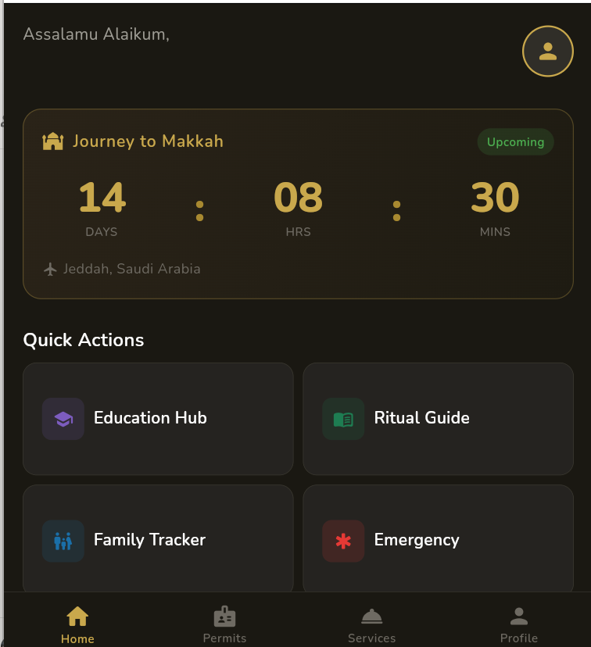
Figure 1 Home Dashboard
Figure 2.1: Home Dashboard
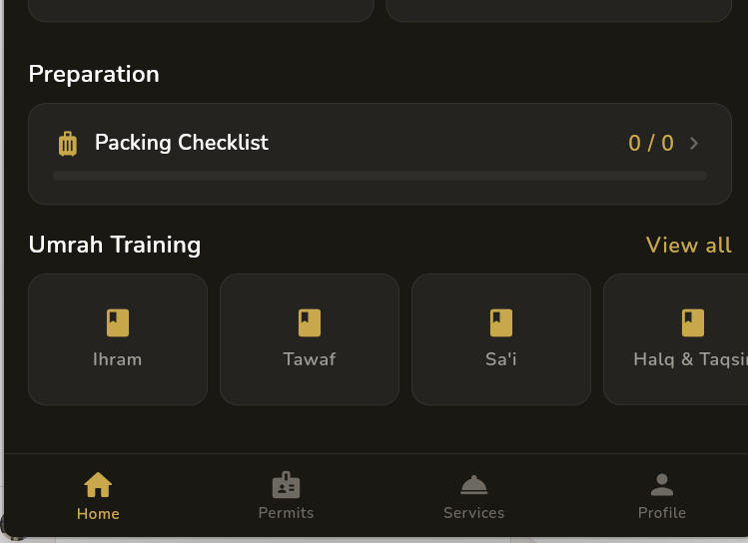
Figure 2 Preparation Section
Figure 2.2: Home Dashboard — Preparation & Training Section

2.3.2 Hardware Interfaces
The app uses the phone's internet connection for Firebase and the touchscreen for user input. The camera is not used in this version but can be added later.

2.3.3 Software Interfaces
Table 6 Software Interface
Library | Version | Purpose
Flutter SDK | 3.5+ | Cross-platform UI
firebase_core | 3.6.0 | Firebase setup
firebase_auth | 5.3.1 | User login/registration
cloud_firestore | 5.4.3 | Cloud database
flutter_riverpod | 2.6.1 | State management
go_router | 14.3.0 | App navigation
sqflite | 2.3.3 | Local SQLite database
shared_preferences | 2.3.2 | Small local storage
google_fonts | 6.2.1 | App fonts
intl | 0.19.0 | Date formatting

2.3.4 Communications Interfaces
The app connects to Firebase over HTTPS. All Firestore data is in JSON format. Firebase Auth uses standard OAuth 2.0 tokens. No custom REST API is used.

2.4 System Features

2.4.1 Feature 1 — User Authentication
Priority: High. The user can create an account, log in, and set up their profile. The app checks auth state using Firebase and automatically navigates the user to the right screen.

Functional Requirements:
- FR-01: Users can register with email and password
- FR-02: Email and password must be validated before submission
- FR-03: Users can sign in with registered credentials
- FR-04: New users must complete a profile before accessing the app
- FR-05: Profile data is saved to Firestore with a profileComplete flag
- FR-06: Unauthenticated users are redirected to sign in or onboarding

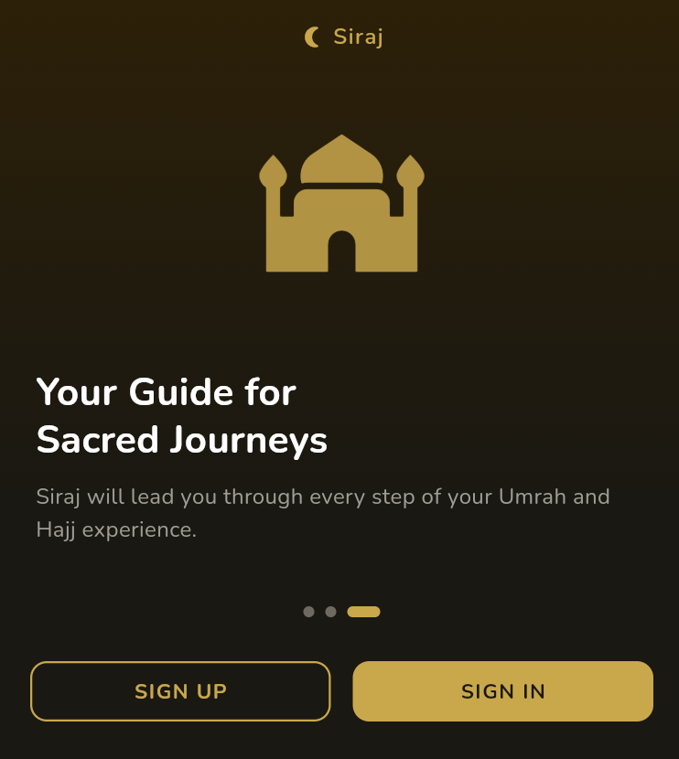
Figure 3 Onboarding Screen
Figure 2.3: Onboarding — Final Slide (Sign Up / Sign In)
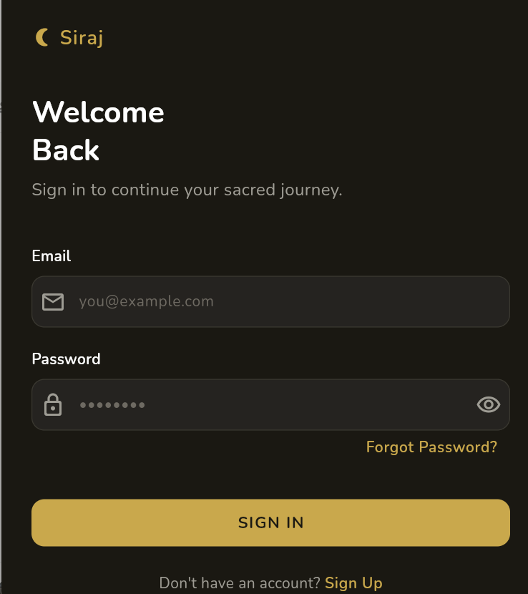
Figure 4 Login Screen
Figure 2.4: Sign In Screen
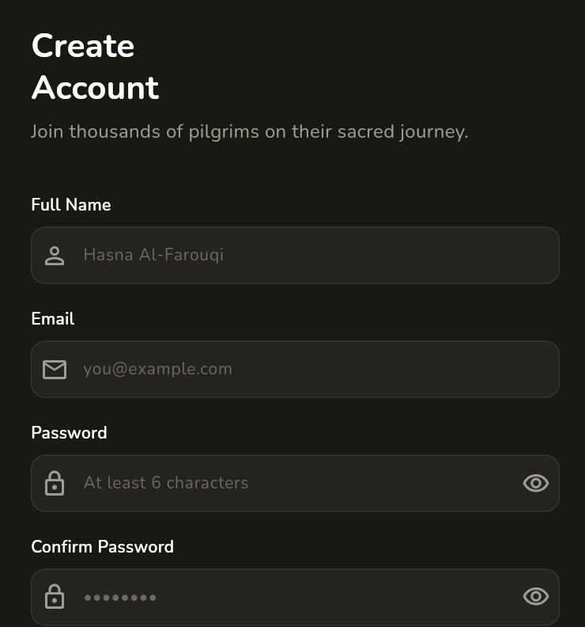
Figure 5 Sign Up Screen
Figure 2.5: Sign Up / Create Account Screen

2.4.2 Feature 2 — Live Ritual Guide
Priority: High. Shows Tawaf and Sa'i steps one by one with Arabic text, transliteration, and English explanation. User can move forward, back, or reset.

- FR-07: Steps show title, Arabic text, transliteration, and instructions
- FR-08: Progress bar shows how far along the user is
- FR-09: Progress is saved between sessions
- FR-10: Sa'i guide shows a separate circuit counter (0 to 7)
- FR-11: Completion screen shown when all steps are done

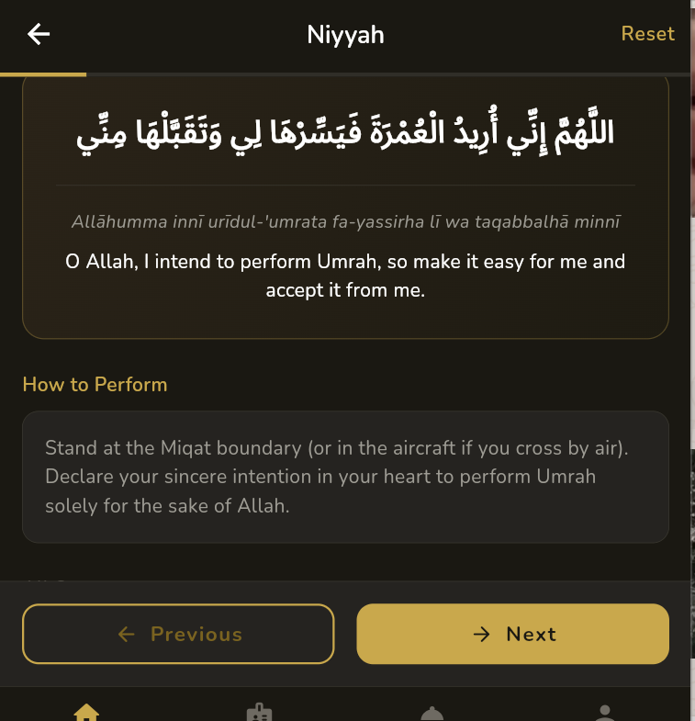
Figure 6 Ritual Guide_Niyyah
Figure 2.6: Ritual Guide — Niyyah Step
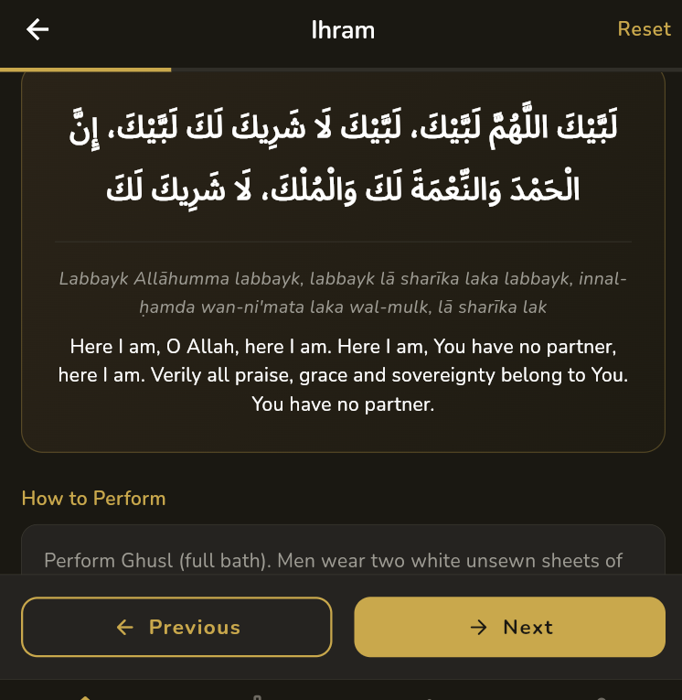
Figure 7 Ritual Guide Ihram Step
Figure 2.7: Ritual Guide — Ihram Step (Talbiyah)
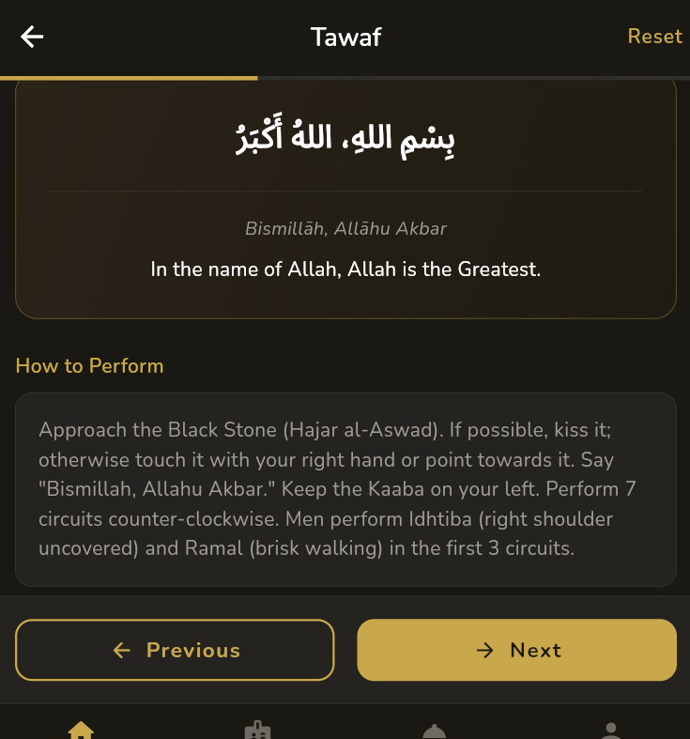
Figure 8 Ritual guide Tawaf
Figure 2.8: Ritual Guide — Tawaf Step

2.4.3 Feature 3 — Hotel Booking
Priority: High. Pilgrims can browse hotels near Masjid Al-Haram with ratings, prices, distance, and amenities from Firebase.
- FR-12: Hotel list loads from Cloud Firestore in real time
- FR-13: Each hotel shows name, location, distance, rating, price, and amenities
- FR-14: Tapping a hotel opens a detail screen
- FR-15: Admin can add, edit, and delete hotels via the admin panel

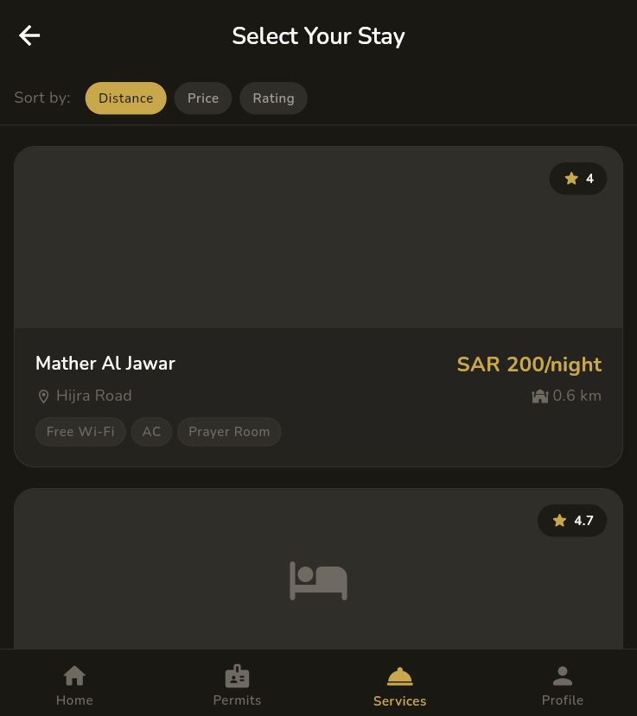
Figure 9 Hotel List
Figure 2.9: Select Your Stay — Hotel Listing

2.4.4 Feature 4 — Digital Permit Wallet
Priority: High. Shows the user's Umrah permits fetched from Firestore with status badges (active/expired).

- FR-16: Permits are loaded from Firestore for the logged-in user
- FR-17: Each permit shows type, holder name, issue/expiry dates, and status
- FR-18: Refresh button re-fetches permit data

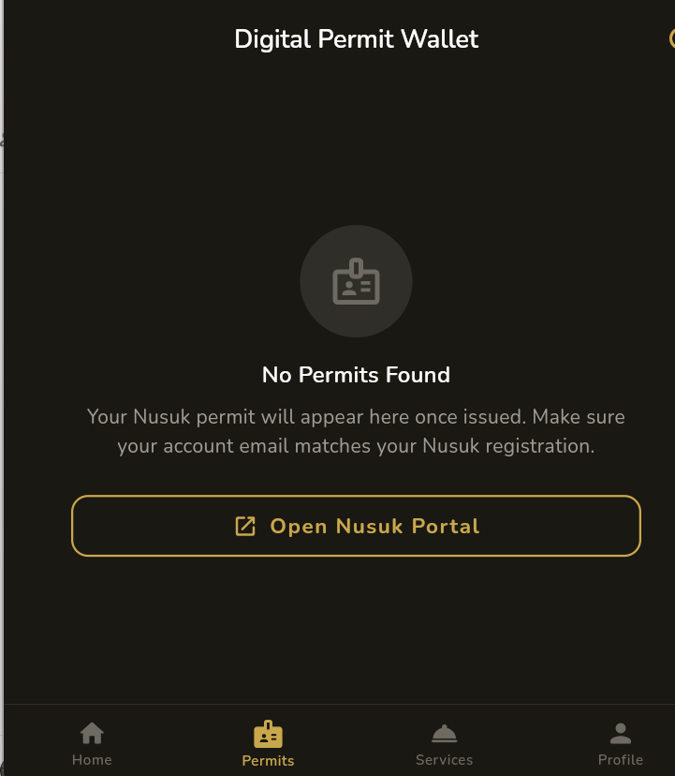
Figure 10 Permit
Figure 2.10: Digital Permit Wallet Screen

2.4.5 Feature 5 — Emergency Assistance
Priority: High. One-tap access to Saudi emergency numbers, nearby hospitals, and embassy info. Long-press SOS button calls emergency services.

- FR-19: Saudi emergency hotlines shown with one-tap call option
- FR-20: Nearby hospitals with distances listed
- FR-21: Long-press SOS button triggers emergency call

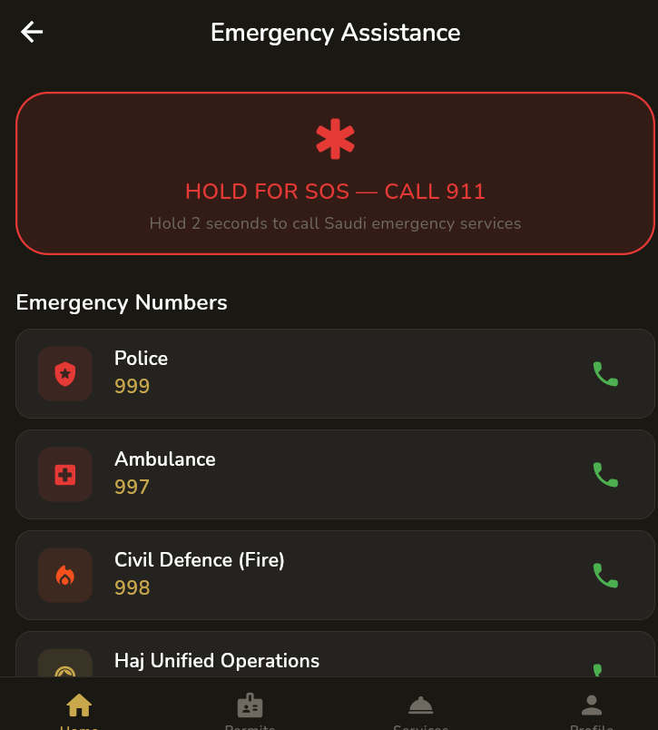
Figure 11 Emergency Assistance
Figure 2.11: Emergency Assistance — SOS & Numbers
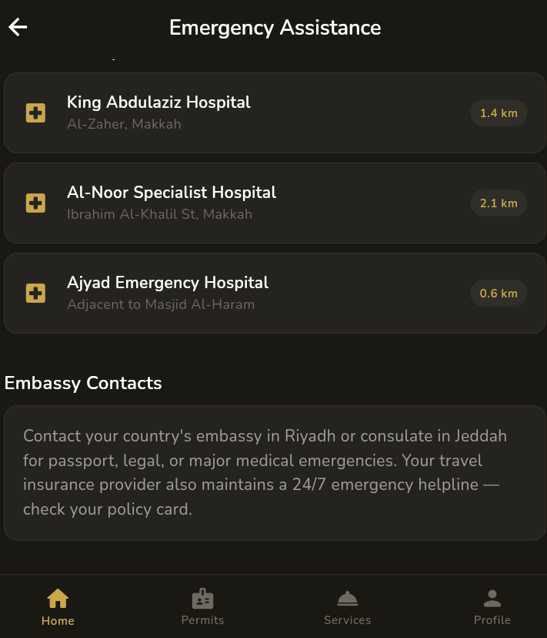
Figure 12 Hospitals
Figure 2.12: Emergency Assistance — Hospitals & Embassy

2.5 Non-Functional Requirements

2.5.1 Performance
- NFR-01: Home screen loads within 2 seconds on a mid-range phone
- NFR-02: Firebase queries complete within 3 seconds on a normal network
- NFR-03: Ritual guide and checklist (SQLite) load within 500ms

2.5.2 Safety
- NFR-04: Emergency numbers must be correct and up to date
- NFR-05: Ritual content must follow authentic Islamic sources

2.5.3 Security
- NFR-06: Passwords are handled by Firebase only — never stored locally
- NFR-07: Firestore rules restrict users to their own data
- NFR-08: All communication goes over HTTPS

2.5.4 Software Quality Attributes
Table 7 Attributes
Attribute | Description | How I handled it
Reliability | Works correctly in all scenarios | Error handling on every async call
Maintainability | Easy to understand and modify | Feature-based folder structure, Riverpod providers
Usability | Easy for any pilgrim to use | Material 3 patterns, onboarding, clear navigation
Portability | Works on Android and iOS | Flutter cross-platform
Scalability | Can handle more users and features | Firebase scales automatically
Offline Support | Core features work without internet | SQLite for rituals and checklists

2.5.5 Business Rules
- Only logged-in users with completed profiles can use the main app
- Admin routes are separate and have their own login
- Only admins can add or edit hotel listings

2.6 Other Requirements
The app supports English as the main language. Arabic text is shown for ritual duas and Quranic verses. The app must follow Google Play and Apple App Store guidelines for content and privacy.

Chapter 3 Use Case Analysis

3.1 Use Case Model
The use case diagram below shows all the main ways users interact with Umrah Ease. There are three actors: the Pilgrim (regular user), the Admin, and Firebase (external backend system).

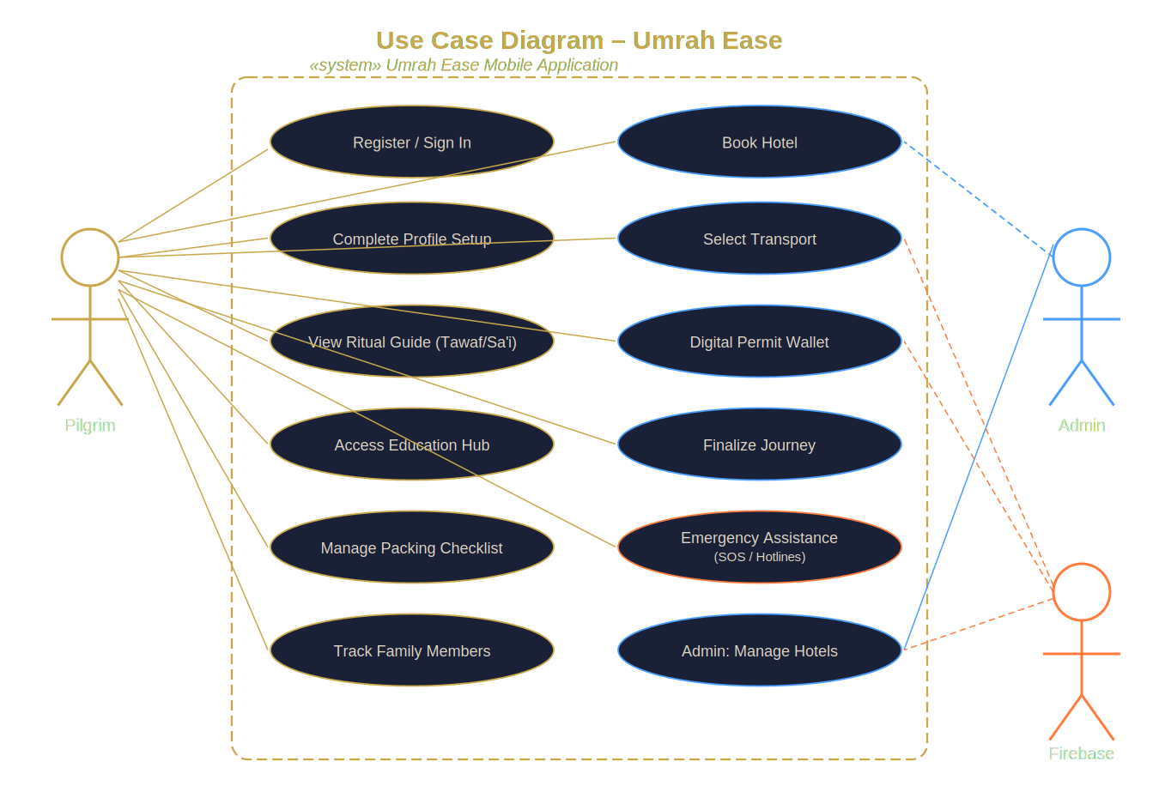
Figure 13 Use Case Diagram
Figure 3.1: Use Case Diagram — Umrah Ease

3.2 Use Case Descriptions

UC-01: User Registration
Table 8 User Registration
Field | Details
Use Case ID | UC-01
Name | User Registration
Actor | Pilgrim
Precondition | User has not registered before
Basic Flow | 1. App opens → Onboarding shown 2. User taps "Get Started" → Sign Up screen 3. User fills name, email, password → Submits 4. Firebase creates account → Profile Setup shown 5. User fills profile → Saved to Firestore → Home Dashboard
Alt Flow | Email already used → Error shown → Redirect to Sign In
Exception | No internet → Error message → Retry option
Postcondition | Account created in Firebase, profile stored in Firestore

UC-02: View Ritual Guide
Table 9 Ritual Guide
Field | Details
Use Case ID | UC-02
Name | View Live Ritual Guide
Actor | Pilgrim
Precondition | User is logged in with a complete profile
Basic Flow | 1. Tap "Ritual Guide" on Home 2. Steps load from SQLite database 3. First step shown 4. User taps Next → next step shown 5. Progress bar updates 6. After last step → Completion screen shown
Alt Flow | Tap Reset → Progress goes back to step 1
Exception | SQLite read fails → Error shown → Retry available
Postcondition | User progressed through ritual steps

UC-03: Book Hotel
Table 10 Book Hotel
Field | Details
Use Case ID | UC-03
Name | Book Hotel
Actor | Pilgrim
Precondition | User logged in, hotels exist in Firestore
Basic Flow | 1. Go to Services → Select Your Stay 2. Hotel list loads from Firestore 3. User browses, taps a hotel → Details shown 4. User confirms → Goes to Finalize Journey
Alt Flow | No Firestore data → Mock list shown as fallback
Exception | No internet → Error with retry option
Postcondition | Hotel selected, user continues to journey finalization

UC-04: Admin Manage Hotels
Table 11 Admin
Field | Details
Use Case ID | UC-04
Name | Manage Hotels (Admin)
Actor | Administrator
Precondition | Admin logged in via admin login screen
Basic Flow | 1. Admin opens /admin-login, enters credentials 2. Admin Dashboard shown 3. Tap "Add Hotel" → Fill form → Save to Firestore 4. Tap "View Hotels" → List shown 5. Tap Edit → Update details → Save 6. Tap Delete → Confirm → Removed from Firestore
Alt Flow | Incomplete form → Validation errors shown
Exception | Firestore write fails → Error → Retry
Postcondition | Hotel collection in Firestore updated

Chapter 4 System Design

4.1 Architecture Diagram
Umrah Ease has a 3-layer architecture. The Presentation Layer is the Flutter UI. The Business Logic Layer is the Riverpod providers and GoRouter. The Data Layer is Firebase Firestore + SQLite.

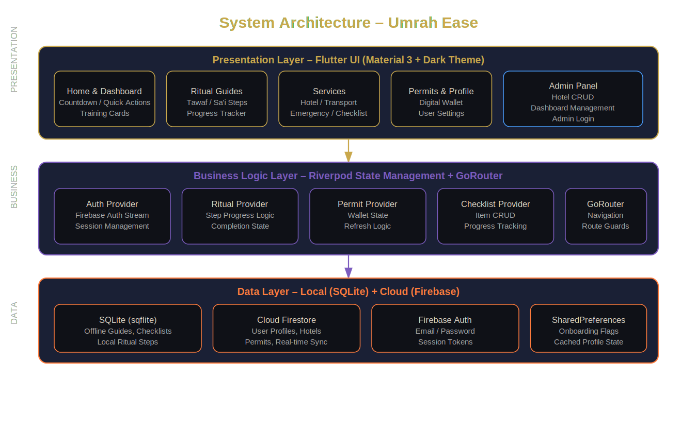
Figure 14 System Architecture
Figure 4.1: System Architecture Diagram

4.2 Domain Model
The five main data objects in the app are: UserProfile, Hotel, RitualStep, Permit, and ChecklistItem. A UserProfile has many ChecklistItems and follows multiple RitualSteps. Hotels are managed by admins. Permits belong to a specific user.

4.3 Entity Relationship Diagram with Data Dictionary
Table 12 Entity Table
Entity | Key Fields | Stored In | Relationship
UserProfile | uid, displayName, email, isFirstTimer, groupSize, language | Firestore (users/) | Has-many: Permits; ChecklistItems (local)
Hotel | id, name, location, distanceKm, pricePerNight, rating, amenities | Firestore (hotels/) | Managed by Admin; Viewed by Pilgrim
RitualStep | id, ritualGroup, title, arabicText, transliteration, instructions | SQLite | Belongs to Tawaf or Sa'i group
Permit | id, permitType, holderName, issueDate, expiryDate, status | Firestore (users/{uid}/permits) | Belongs to UserProfile
ChecklistItem | id, label, category, isChecked | SQLite | Belongs to User (local)
UmrahGuide | id, title, category, content | SQLite | Used by Education Hub
TransportOption | id, type, provider, pricePerSeat | Static/Firestore | Selected during finalization

4.4 Class Diagram
The class diagram below shows the main model classes, their attributes and methods, and how they relate to each other.

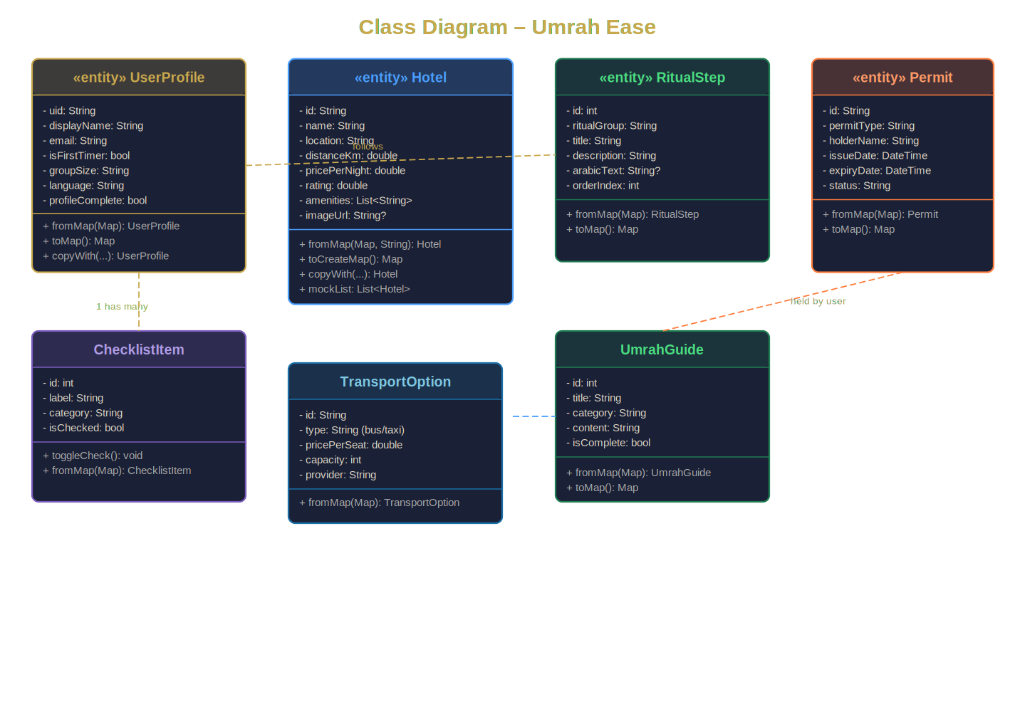
Figure 15 Class Diagram
Figure 4.2: Class Diagram — Data Models

4.5 Sequence / Collaboration Diagram
The login and routing flow works like this:
- User opens the app and the system checks the onboarding status from local storage.
- The app then checks the authentication state using Firebase Authentication.
- If the user is not logged in, they are redirected to the onboarding or sign-in screen.
- The user enters their login credentials and submits the form.
- Firebase Authentication verifies the credentials.
- After successful login, the system fetches the user profile from Firestore.
- If the profile is complete, the user is redirected to the home screen; otherwise, they are taken to the profile setup screen.
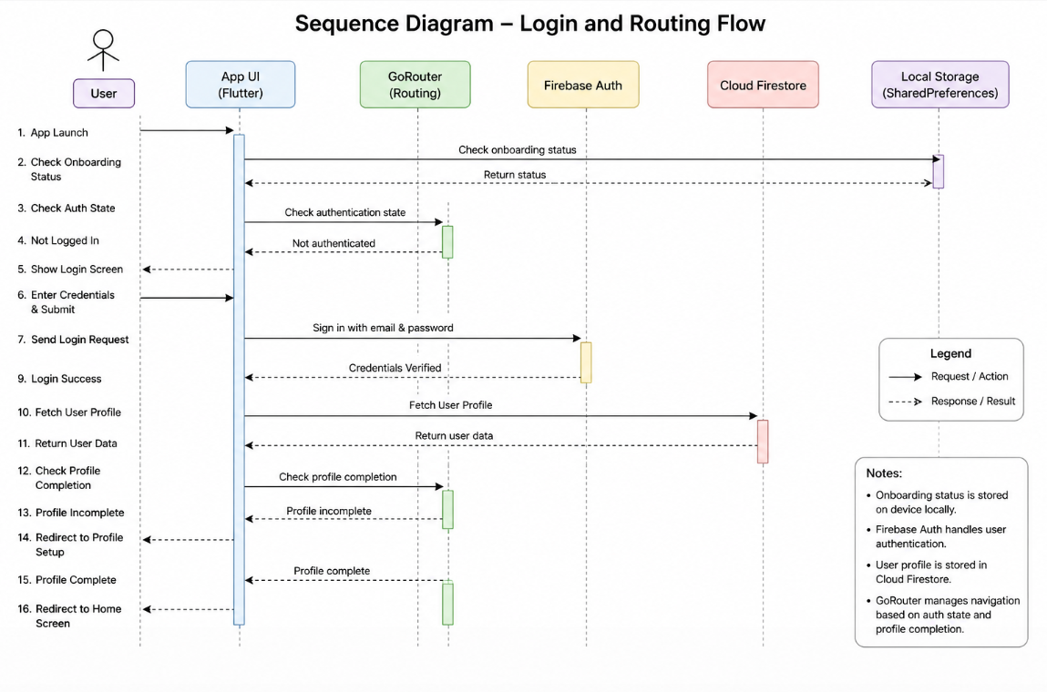
Figure 16 Sequence Diagram

4.6 Operation Contracts
Table 13 Operation Contracts
Operation | Pre-condition | Post-condition
signIn(email, password) | User not logged in | Firebase session started, auth stream updates
completeProfile(data) | User logged in, no Firestore profile | Firestore profile created with profileComplete=true
nextRitualStep() | Provider loaded, not at last step | currentIndex increases by 1, UI re-renders
reset() | Provider loaded | currentIndex resets to 0
refreshPermits() | User logged in | Firestore query runs, permitProvider updates
addHotel(hotel) | Admin logged in, valid data | New document added to hotels collection
toggleChecklistItem(id) | Item exists in SQLite | isChecked toggled, SQLite updated, progress recalculated

4.7 Activity Diagram
The activity diagram below shows the full user journey from opening the app through login, feature selection, and completing a task.
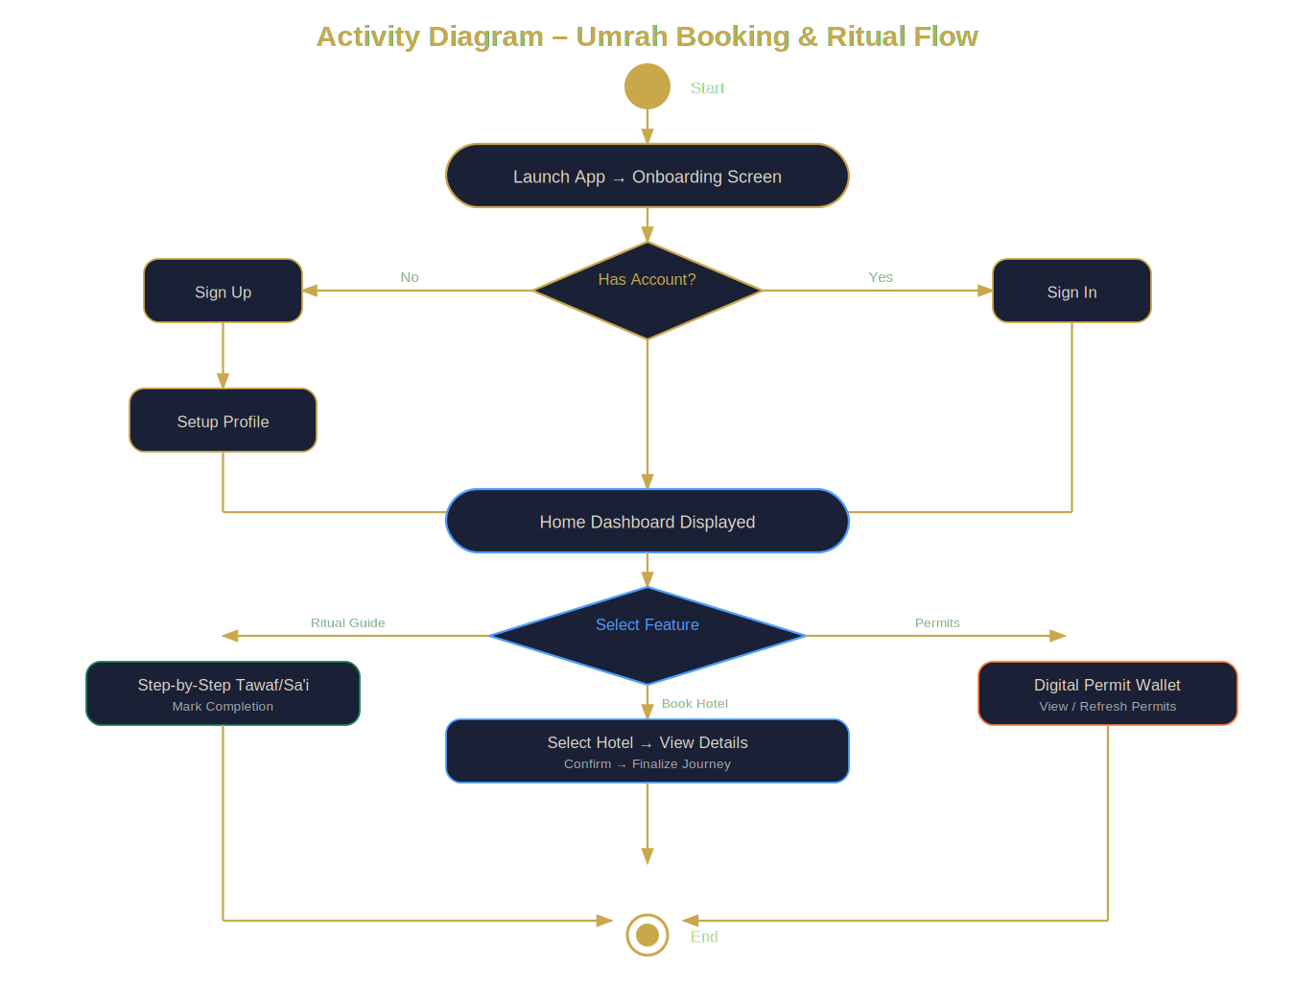
Figure 17 Activity Diagram
Figure 4.3: Activity Diagram — Core User Flow

4.8 State Transition Diagram
The RitualGuideProvider has these states:
Table 14 Transition
State | Description | Transitions
LOADING | Fetching steps from SQLite | → STEP_0 on success
STEP_N | Showing step N | → STEP_N+1 on Next; → STEP_0 on Reset
STEP_MAX | Last step | → COMPLETED on Next; → STEP_0 on Reset
COMPLETED | All done, completion screen shown | → STEP_0 on Reset
ERROR | SQLite read failed | → LOADING on retry

4.9 Components
The app is split into these main components:
- UI Layer: Feature folders under lib/features/, each with screens/ and providers/
- Shared Providers: lib/shared/providers/ — Firebase, Auth, SharedPrefs providers
- Data Layer: Models in lib/data/models/, repos in lib/data/repositories/
- Admin Panel: Self-contained in lib/admin/ with its own login flow
- Core: App-wide theme, colors, and constants in lib/core/

4.10 Deployment
The app has two tiers:
- Client Tier: Flutter app installed on the user's phone (Android APK) SQLite and SharedPreferences are stored locally.
- Cloud Tier: Firebase on Google Cloud infrastructure — Auth for login sessions, Firestore for hotel/user/permit data, Storage for images (future).
Table 15 Deployement
Node | Component | Technology
Android/iOS Device | Umrah Ease App | Flutter (compiled native)
Device — Local Storage | SQLite Database | sqflite package
Device — Preferences | Onboarding flags | SharedPreferences
Firebase / Google Cloud | Authentication | Firebase Auth
Firebase / Google Cloud | Cloud Database | Firestore
Android Device (APK) | Application Distribution | Signed APK/IPA

Chapter 5 Implementation

5.1 Important Flow Control / Pseudo Codes

5.1.1 GoRouter Authentication Redirect Logic
This is the redirect logic in app_router.dart that decides where to send the user based on their login state:

FUNCTION _redirect(ref, state):
loc = current route path
IF loc starts with "/admin": RETURN null // Admin bypasses auth
user = read Firebase auth state
IF user is null:
IF loc is onboarding/signIn/signUp: RETURN null
IF onboarding done = true: RETURN signIn ELSE: RETURN onboarding
profile = read Firestore user profile
IF profile incomplete:
IF loc == profileSetup: RETURN null ELSE: RETURN profileSetup
IF loc in auth screens: RETURN home ELSE: RETURN null

5.1.2 Ritual Guide State Logic
This is how the RitualGuideNotifier (Riverpod) works inside ritual_provider.dart:

CLASS RitualGuideNotifier extends Notifier<RitualGuideState>:
FUNCTION build(): RETURN RitualGuideState(steps: _umrahSteps, index: 0)
FUNCTION next():
IF currentIndex < steps.length-1: state = copyWith(index+1)
FUNCTION previous():
IF currentIndex > 0: state = copyWith(index-1)
FUNCTION reset(): state = copyWith(index: 0)
COMPUTED progressFraction: RETURN (currentIndex+1) / steps.length

5.2 Components, Libraries, and Web Services
Table 16 Components
Library | Package | Version | What it does
State Management | flutter_riverpod + riverpod_annotation | 2.6.1 | Manages all app state using providers
Navigation | go_router | 14.3.0 | Handles routing with auth guards and nested navigation
Cloud DB | cloud_firestore | 5.4.3 | Stores hotels, user profiles, permits
Authentication | firebase_auth | 5.3.1 | Handles email/password login with state streams
Local DB | sqflite + path | 2.3.3 | SQLite for offline rituals, guides, checklists
Typography | google_fonts | 6.2.1 | App-wide font loading
Local Storage | shared_preferences | 2.3.2 | Stores onboarding/profile flags
Formatting | intl | 0.19.0 | Formats permit dates
Code Gen | build_runner + riverpod_generator | 2.4.3 | Auto-generates Riverpod provider code

5.3 Deployment Environment
Table 17 Deployment Environment
Item | Details
IDE | Android Studio with Flutter & Dart plugins
Flutter SDK | Flutter 3.x (Dart 3.5+)
Target Platforms | Android (primary), iOS (planned)
Test Device | Physical Android device + Android 13 emulator
Firebase Project | umrah-ease (Firebase Console)
Version Control | Git with GitHub
Build Type | Debug (dev), Release --obfuscate (production)

5.4 Tools and Techniques
- Flutter & Dart: Main dev stack, widget-based declarative UI
- Firebase Console: Firestore data management and Auth configuration
- Android Studio: Primary IDE for development and debugging
- Git & GitHub: Source code version control
- build_runner: Code generation for Riverpod providers

5.5 Best Practices / Coding Standards
- Feature-based folder structure: lib/features/feature_name/screens/ and providers/
- No business logic in UI widgets — all state in Riverpod providers
- All state objects use copyWith() for safe updates
- All async Firebase/SQLite calls have try-catch error handling
- Loading indicators shown while data is being fetched
- const constructors used wherever possible for better performance
- Shared styles defined centrally in AppTextStyles, AppColors, AppConstants
- Full Dart null safety enforced across the codebase

5.6 Version Control
The project is managed with Git and hosted on GitHub. I used a simple workflow: main branch for stable code, feature/* branches for new work. Commit messages are descriptive and verb-first (e.g., "Add hotel detail screen"). The .gitignore excludes firebase_options.dart, build/, and .idea/.

5.7 Source Code of Main Screens
Below are the source code listings for the most important screens in Umrah Ease. These show the actual implementation from the lib/ folder of the Flutter project.

5.7.1 Sign In Screen (sign_in_screen.dart)
This screen handles user login using Firebase Authentication. It has email/password form fields with validation, a Forgot Password dialog, and a loading state while waiting for Firebase.

class SignInScreen extends ConsumerStatefulWidget {
const SignInScreen({super.key});

@override
ConsumerState<SignInScreen> createState() => _SignInScreenState();
}

class _SignInScreenState extends ConsumerState<SignInScreen> {
final _formKey = GlobalKey<FormState>();
final _emailCtrl = TextEditingController();
final _passwordCtrl = TextEditingController();
bool _obscurePassword = true;
final _resetEmailCtrl = TextEditingController();

@override
void dispose() {
_emailCtrl.dispose();
_passwordCtrl.dispose();
_resetEmailCtrl.dispose();
super.dispose();
}

Future<void> _showForgotPassword() async {
_resetEmailCtrl.text = _emailCtrl.text.trim();
await showDialog<void>(
context: context,
builder: (ctx) => AlertDialog(
backgroundColor: AppColors.backgroundDark,
title: Text('Reset Password', style: AppTextStyles.titleLarge),
content: Column(
mainAxisSize: MainAxisSize.min,
crossAxisAlignment: CrossAxisAlignment.start,
children: [
Text(
'Enter your email address and we\'ll send you a link to reset your password.',
style: AppTextStyles.bodyMedium,
),
const SizedBox(height: 16),
TextField(
controller: _resetEmailCtrl,
keyboardType: TextInputType.emailAddress,
autocorrect: false,
style: AppTextStyles.bodyMedium.copyWith(color: AppColors.textPrimary),
decoration: const InputDecoration(
hintText: 'you@example.com',
prefixIcon: Icon(Icons.email_outlined),
),
),
],
),
actions: [
TextButton(
onPressed: () => Navigator.of(ctx).pop(),
child: Text('Cancel', style: AppTextStyles.bodyMedium),
),
TextButton(
onPressed: () async {
final email = _resetEmailCtrl.text.trim();
const pattern = r'^[a-zA-Z0-9._%+\-]+@[a-zA-Z0-9.\-]+\.[a-zA-Z]{2,}$';
if (!RegExp(pattern).hasMatch(email)) {
ScaffoldMessenger.of(context).showSnackBar(
const SnackBar(content: Text('Enter a valid email address.')),
);
return;
}
Navigator.of(ctx).pop();
await ref.read(authNotifierProvider.notifier).resetPassword(email);
if (mounted) {
ScaffoldMessenger.of(context).showSnackBar(
const SnackBar(
content: Text('If an account exists, a reset link has been sent.'),
),
);
}
},
child: Text('Send Link', style: AppTextStyles.goldLabel),
),
],
),
);
}


Figure 18 Sign In Screen
Figure 5.1: Sign In Screen Output

5.7.2 Home Screen (home_screen.dart)
The home screen shows the journey countdown, quick action buttons, packing checklist progress, and Umrah training categories. It reads from three Riverpod providers simultaneously.
import 'package:flutter/material.dart';
import 'package:flutter_riverpod/flutter_riverpod.dart';
import 'package:go_router/go_router.dart';

import '../../../app_router.dart';
import '../../../core/constants/app_constants.dart';
import '../../../core/theme/app_colors.dart';
import '../../../core/theme/app_text_styles.dart';
import '../../../features/auth/providers/user_profile_provider.dart';
import '../../../features/checklist/providers/checklist_provider.dart';
import '../../../features/education/providers/training_provider.dart';

class HomeScreen extends ConsumerWidget {
const HomeScreen({super.key});

@override
Widget build(BuildContext context, WidgetRef ref) {
final profileAsync = ref.watch(currentUserProfileProvider);
final guidesAsync = ref.watch(trainingProvider);
final (checked, total) = ref.watch(checklistProgressProvider);

return Scaffold(
backgroundColor: AppColors.backgroundDark,
body: SafeArea(
child: CustomScrollView(
slivers: [
// ── Header ──────────────────────────────────────────────────────
SliverToBoxAdapter(
child: _Header(profileAsync: profileAsync),
),

// ── Journey countdown ────────────────────────────────────────────
const SliverToBoxAdapter(child: _CountdownCard()),

// ── Quick actions grid ───────────────────────────────────────────
SliverToBoxAdapter(
child: Padding(
padding: const EdgeInsets.fromLTRB(
AppConstants.spaceMD, 0, AppConstants.spaceMD, 0),
child: Column(
crossAxisAlignment: CrossAxisAlignment.start,
children: [
Text('Quick Actions', style: AppTextStyles.titleMedium),
const SizedBox(height: AppConstants.spaceSM),
_QuickActionsGrid(),
],
),
),
),

const SliverToBoxAdapter(
child: SizedBox(height: AppConstants.spaceLG)),

// ── Preparation progress ─────────────────────────────────────────
SliverToBoxAdapter(
child: _SectionHeader(title: 'Preparation'),
),
SliverToBoxAdapter(
child: Padding(
padding: const EdgeInsets.symmetric(
horizontal: AppConstants.spaceMD),
child: _ProgressCard(
label: 'Packing Checklist',
icon: Icons.luggage_rounded,
checked: checked,
total: total,
onTap: () => context.push(AppRoutes.packingChecklist),
),
),
),

const SliverToBoxAdapter(
child: SizedBox(height: AppConstants.spaceMD)),

// ── Training overview ────────────────────────────────────────────
SliverToBoxAdapter(
child: _SectionHeader(
title: 'Umrah Training',
action: 'View all',
onAction: () => context.push(AppRoutes.educationHub),
),
),
SliverToBoxAdapter(
child: guidesAsync.when(
loading: () => const _ShimmerCard(),
error: (_, __) => const SizedBox.shrink(),
data: (guides) {
final categories =
guides.map((g) => g.category).toSet().toList();
return SizedBox(
height: 88,
child: ListView.separated(
scrollDirection: Axis.horizontal,
padding: const EdgeInsets.symmetric(
horizontal: AppConstants.spaceMD),
itemCount: categories.length,
separatorBuilder: (_, __) =>
const SizedBox(width: AppConstants.spaceSM),
itemBuilder: (_, i) =>
_CategoryChip(label: categories[i]),
),
);
},
),
),


Figure 19 Home Screen Output
Figure 5.2: Home Screen Output

5.7.3 Ritual Guide Provider (ritual_provider.dart)
This Riverpod Notifier manages all the Umrah ritual steps. Steps are stored as static constants so they work offline. The provider handles moving forward, back, and resetting.

class RitualGuideState {
const RitualGuideState({
required this.steps,
required this.currentIndex,
});

final List<RitualStep> steps;
final int currentIndex;

RitualStep get current => steps[currentIndex];
bool get isFirst => currentIndex == 0;
bool get isLast => currentIndex == steps.length - 1;

double get progressFraction =>
steps.isEmpty ? 0 : (currentIndex + 1) / steps.length;

RitualGuideState copyWith({int? currentIndex}) => RitualGuideState(
steps: steps,
currentIndex: currentIndex ?? this.currentIndex,
);
}

// ── Notifier ──────────────────────────────────────────────────────────────────

class RitualGuideNotifier extends Notifier<RitualGuideState> {
@override
RitualGuideState build() => const RitualGuideState(
steps: _umrahSteps,
currentIndex: 0,
);

void next() {
if (!state.isLast) {
state = state.copyWith(currentIndex: state.currentIndex + 1);
}
}

void previous() {
if (!state.isFirst) {
state = state.copyWith(currentIndex: state.currentIndex - 1);
}
}

void jumpTo(int index) {
if (index >= 0 && index < state.steps.length) {
state = state.copyWith(currentIndex: index);
}
}

void reset() => state = state.copyWith(currentIndex: 0);
}

final ritualGuideProvider =
NotifierProvider<RitualGuideNotifier, RitualGuideState>(
RitualGuideNotifier.new,
name: 'ritualGuideProvider',
);

// ── Sa'i counter ──────────────────────────────────────────────────────────────

class SaiCounterNotifier extends Notifier<int> {
@override
int build() => 0;

void increment() {
if (state < 7) state++;
}

void reset() => state = 0;
}

final saiCounterProvider = NotifierProvider<SaiCounterNotifier, int>(
SaiCounterNotifier.new,
name: 'saiCounterProvider',
);


Figure 20 Ritual screen Output
Figure 5.3: Ritual Guide Screen (Tawaf Step)
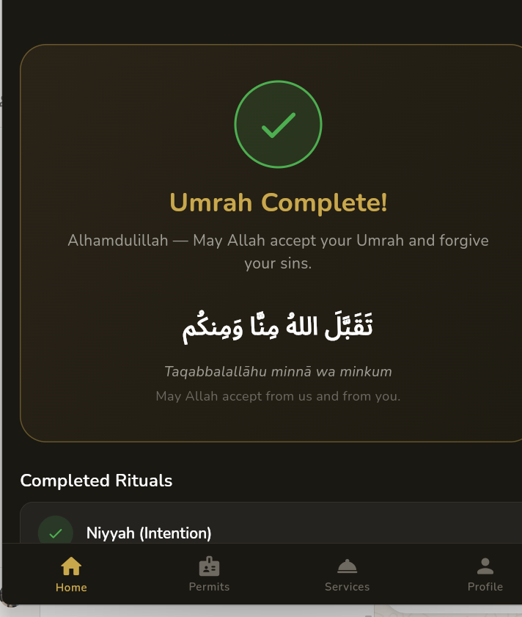
Figure 21 Umrah Completed
Figure 5.4: Ritual Completion Screen

5.7.4 Emergency Screen (emergency_screen.dart)
This screen shows the SOS button, Saudi emergency hotlines, nearby hospitals, and embassy info. The SOS button uses a long-press gesture to prevent accidental activation.

class EmergencyScreen extends StatelessWidget {
const EmergencyScreen({super.key});

@override
Widget build(BuildContext context) {
return Scaffold(
backgroundColor: AppColors.backgroundDark,
appBar: AppBar(title: const Text('Emergency Assistance')),
body: SingleChildScrollView(
padding: const EdgeInsets.all(AppConstants.spaceMD),
child: Column(
crossAxisAlignment: CrossAxisAlignment.stretch,
children: [
// ── SOS button ────────────────────────────────────────────────
_SosButton(),

const SizedBox(height: AppConstants.spaceLG),

// ── Saudi emergency numbers ───────────────────────────────────
Text('Emergency Numbers', style: AppTextStyles.titleMedium),
const SizedBox(height: AppConstants.spaceSM),
..._saudiContacts.map((c) => _ContactCard(contact: c)),

const SizedBox(height: AppConstants.spaceLG),

// ── Nearest hospitals ─────────────────────────────────────────
Text('Nearest Hospitals', style: AppTextStyles.titleMedium),
const SizedBox(height: AppConstants.spaceSM),
..._hospitals.map((h) => _HospitalCard(hospital: h)),

const SizedBox(height: AppConstants.spaceLG),

// ── Embassies ─────────────────────────────────────────────────
Text('Embassy Contacts', style: AppTextStyles.titleMedium),
const SizedBox(height: AppConstants.spaceSM),
Container(
padding: const EdgeInsets.all(AppConstants.spaceMD),
decoration: BoxDecoration(
color: AppColors.surface,
borderRadius:
BorderRadius.circular(AppConstants.radiusMD),
border:
Border.all(color: AppColors.cardBorder, width: 0.5),
),
child: Text(
'Contact your country\'s embassy in Riyadh or consulate in Jeddah for passport, legal, or major medical emergencies. Your travel insurance provider also maintains a 24/7 emergency helpline — check your policy card.',
style: AppTextStyles.bodyMedium,
),
),

const SizedBox(height: AppConstants.spaceLG),

// ── Safety tips ───────────────────────────────────────────────
Text('Safety Tips', style: AppTextStyles.titleMedium),
const SizedBox(height: AppConstants.spaceSM),
_SafetyTips(),

const SizedBox(height: AppConstants.spaceXL),
],
),
),
);
}
}


Figure 22 Emergency Screen Output
Figure 5.5: Emergency Screen Output

5.7.5 Admin Dashboard Screen (admin_dashboard_screen.dart)
The admin dashboard is a separate section of the app with its own login. It shows the admin email, and gives options to add or view hotels. The admin can also log out from here.

class AdminDashboardScreen extends ConsumerWidget {
const AdminDashboardScreen({super.key});

Future<void> _logout(BuildContext context, WidgetRef ref) async {
final confirm = await showDialog<bool>(
context: context,
builder: (ctx) => AlertDialog(
backgroundColor: AppColors.surface,
title: Text('Logout', style: AppTextStyles.titleLarge),
content: Text(
'Are you sure you want to logout from the admin panel?',
style: AppTextStyles.bodyMedium,
),
actions: [
TextButton(
onPressed: () => Navigator.of(ctx).pop(false),
child: Text('Cancel', style: AppTextStyles.bodyMedium),
),
TextButton(
onPressed: () => Navigator.of(ctx).pop(true),
child: Text('Logout',
style: AppTextStyles.goldLabel
.copyWith(color: AppColors.error)),
),
],
),
);

if (confirm == true) {
await ref.read(firebaseAuthProvider).signOut();
if (context.mounted) context.go(AppRoutes.adminLogin);
}
}

@override
Widget build(BuildContext context, WidgetRef ref) {
final user = ref.watch(currentUserProvider);

return Scaffold(
backgroundColor: AppColors.backgroundDark,
appBar: AppBar(
title: const Text('Admin Dashboard'),
automaticallyImplyLeading: false,
actions: [
IconButton(
onPressed: () => _logout(context, ref),
icon: const Icon(Icons.logout_rounded),
tooltip: 'Logout',
),
],
),
body: SingleChildScrollView(
padding: const EdgeInsets.all(AppConstants.spaceMD),
child: Column(
crossAxisAlignment: CrossAxisAlignment.start,
children: [
// ── Welcome banner ────────────────────────────────────────────
Container(
width: double.infinity,
padding: const EdgeInsets.all(AppConstants.spaceLG),
decoration: BoxDecoration(
gradient: AppColors.goldGradient,
borderRadius:
BorderRadius.circular(AppConstants.radiusLG),
),
child: Column(
crossAxisAlignment: CrossAxisAlignment.start,
children: [
const Icon(Icons.admin_panel_settings_rounded,
color: AppColors.textOnGold, size: 32),
const SizedBox(height: AppConstants.spaceSM),
Text(
'Welcome, Admin',
style: AppTextStyles.headlineMedium
.copyWith(color: AppColors.textOnGold),
),
if (user?.email != null) ...[
const SizedBox(height: 4),
Text(
user!.email!,
style: AppTextStyles.bodySmall
.copyWith(color: AppColors.textOnGold),
),
],
],
),
),
const SizedBox(height: AppConstants.spaceLG),

Text('Manage Hotels', style: AppTextStyles.titleMedium),
const SizedBox(height: AppConstants.spaceMD),

// ── Action cards ──────────────────────────────────────────────
_ActionCard(
icon: Icons.add_business_rounded,
title: 'Add Hotel',
subtitle: 'Add a new hotel to the Umrah Ease listings',
onTap: () => context.push(AppRoutes.addHotel),
),
const SizedBox(height: AppConstants.spaceMD),
_ActionCard(
icon: Icons.hotel_rounded,
title: 'View Hotels',
subtitle: 'Browse, edit or delete existing hotels',
onTap: () => context.push(AppRoutes.viewHotels),
),
const SizedBox(height: AppConstants.spaceXL),

// ── Logout button ─────────────────────────────────────────────
OutlinedButton.icon(
onPressed: () => _logout(context, ref),
icon: const Icon(Icons.logout_rounded,
color: AppColors.error, size: 18),
label: Text('Logout',
style: AppTextStyles.buttonText
.copyWith(color: AppColors.error)),
style: OutlinedButton.styleFrom(
side: BorderSide(
color: AppColors.error.withValues(alpha: 0.5)),
),
),
],
),
),
);
}
}

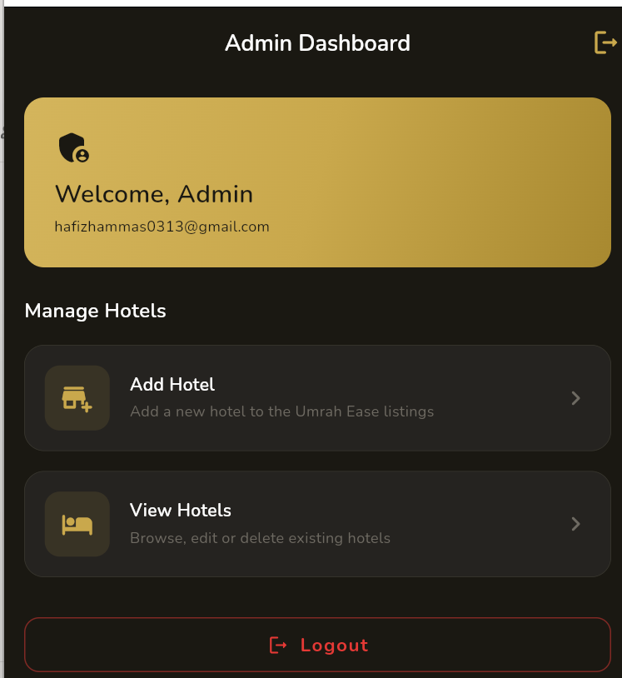
Figure 23 Admin Dashboard Output
Figure 5.6: Admin Dashboard Output
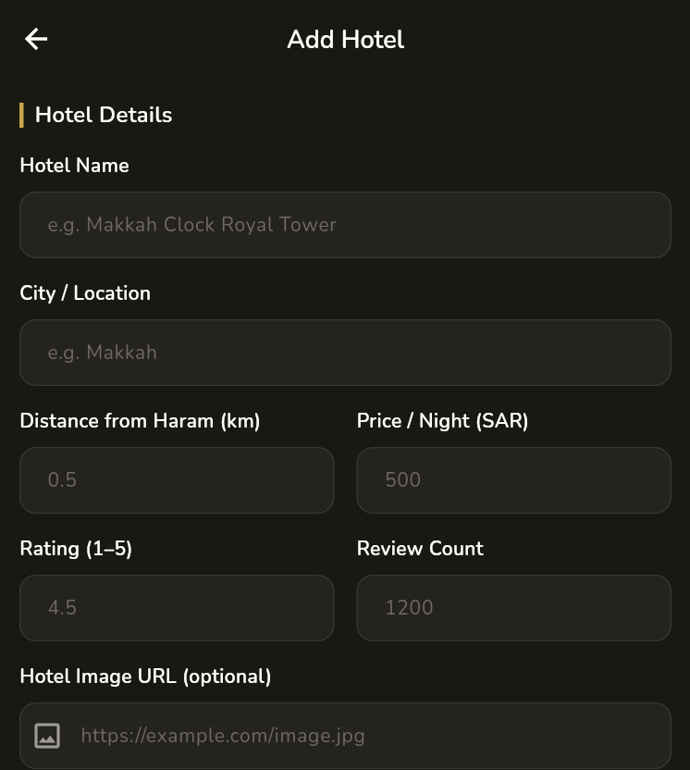
Figure 24 Add hotel Screen
Figure 5.7: Add Hotel Form (Admin)

5.7.6 Other Key Screens — Screenshots
The following screenshots show the remaining important screens of the application:

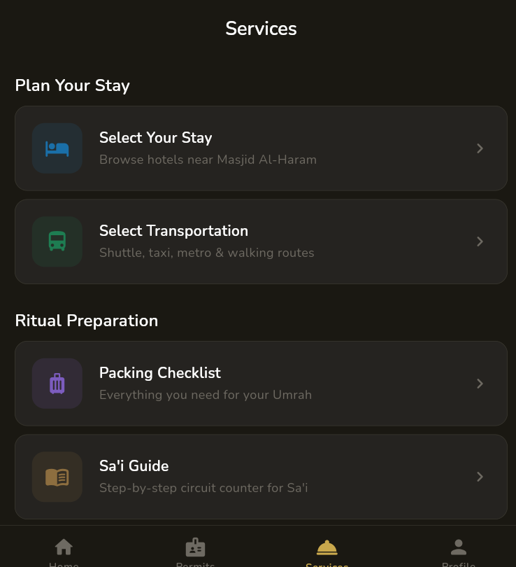
Figure 25 Plan Your Stay
Figure 5.8: Services Screen — Plan Your Stay, Transport, Checklist, Sa'i Guide
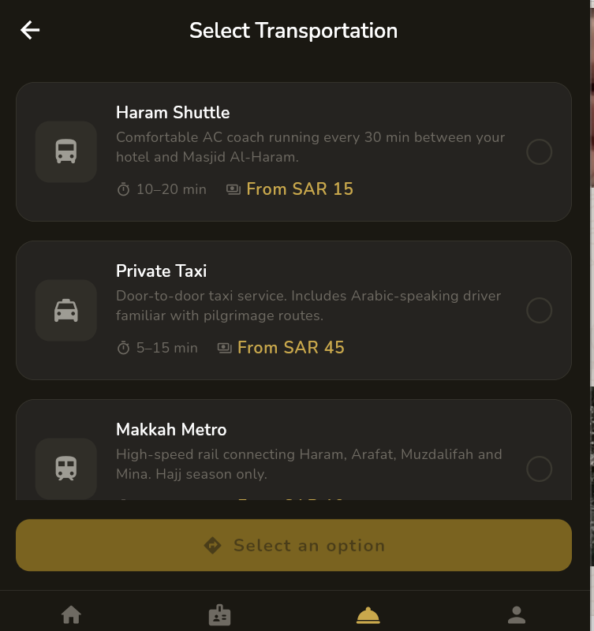
Figure 26 Select Transportation
Figure 5.9: Select Transportation Screen
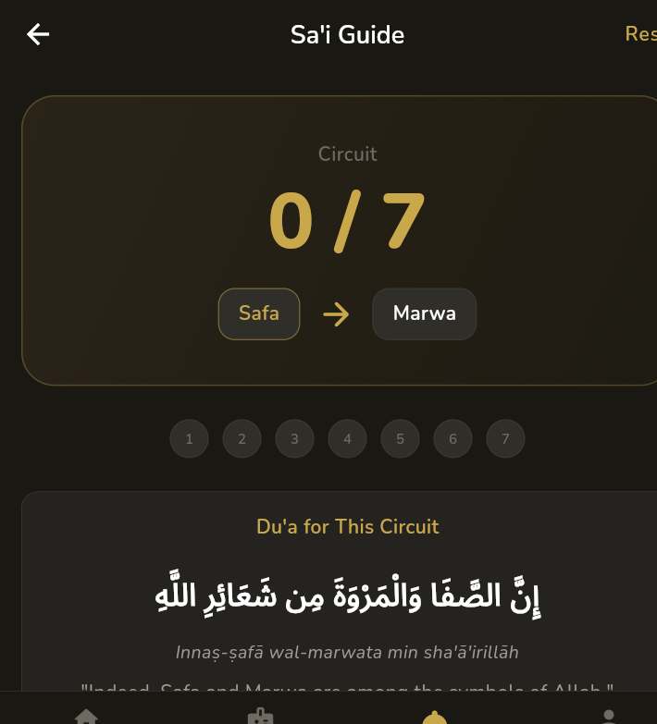
Figure 27 Sa'i Guide
Figure 5.10: Sa'i Guide — Circuit Counter (0/7)
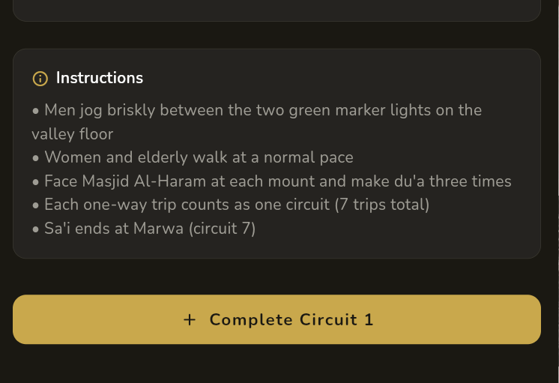
Figure 28 Sa'i Guide Instructions
Figure 5.11: Sa'i Guide — Circuit Instructions & Complete Button
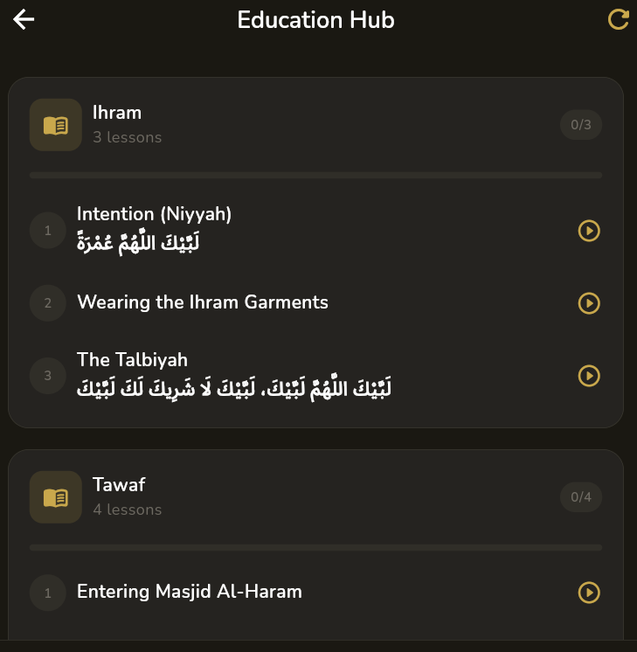
Figure 29 Education Hub
Figure 5.12: Education Hub — Ihram & Tawaf Lessons
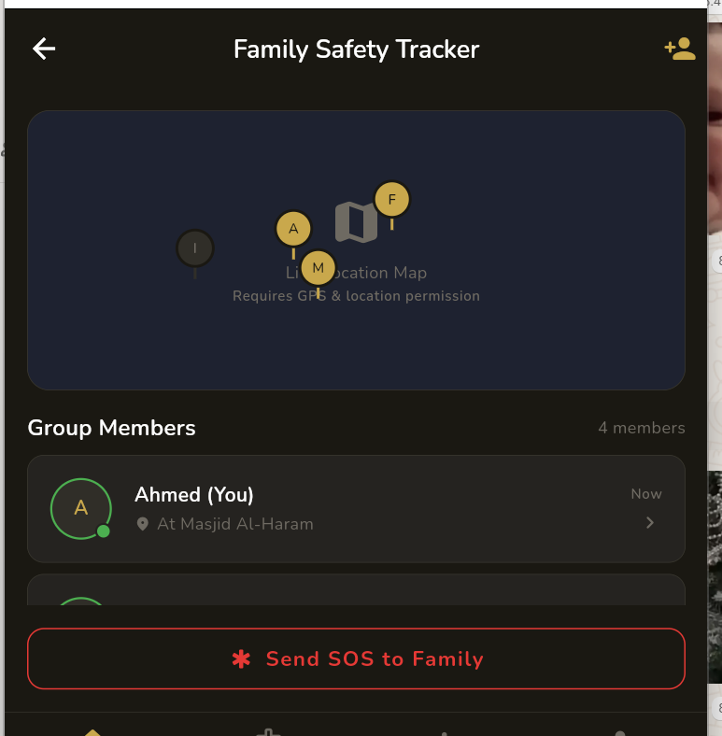
Figure 30 Family Tracker
Figure 5.13: Family Safety Tracker
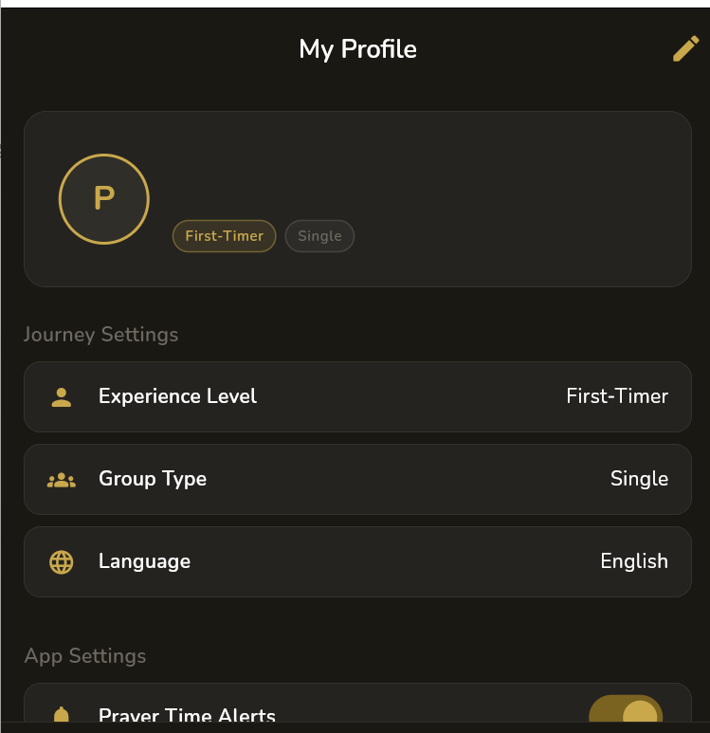
Figure 31 Profile Screen
Figure 5.14: My Profile Screen

Chapter 6 Testing and Evaluation

6.1 Use Case Testing
I tested each use case manually to check it works as expected in both the normal and alternative flows.

Table 18 UseCase Testing
Use Case | Scenario | Expected | Actual | Result
UC-01: Register | Register with valid email + password | Account created, profile setup shown | Profile setup screen shown | PASS
UC-01: Register | Register with already used email | Error message shown | Firebase error shown | PASS
UC-02: Ritual | Go through all Tawaf steps | Completion screen shown | Completion screen appeared | PASS
UC-02: Ritual | Tap Reset | Back to Step 1, 0% progress | Step 1 shown, progress 0% | PASS
UC-03: Hotel | Browse and select hotel | Hotel detail screen shown | Details shown correctly | PASS
UC-04: Admin Add | Submit valid hotel form | Hotel saved to Firestore | Hotel in listing | PASS
UC-04: Admin Add | Submit incomplete form | Validation errors shown | Required field errors shown | PASS

6.2 Equivalence Partitioning
I tested the registration form with valid and invalid input classes to make sure the validation works correctly.

Table 19 Validation
Field | Valid Input | Invalid Input(s) | Test Cases
Email | user@domain.com (valid format) | No @, no domain, empty string | user@test.com ✓; usertest.com ✗; "" ✗
Password | At least 6 characters | Less than 6 chars | Pass123 ✓; pas ✗; 12 ✗
Display Name | 2–50 printable characters | Empty, only spaces | Ahmed ✓; "" ✗
Group Size | single, family, group | Any other value | single ✓; group ✓; xyz ✗

6.3 Boundary Value Analysis
Table 20 Boundry Values
Parameter | Min | Max | Test Min | Test Max | Result
Password Length | 6 chars | 128 chars | 6-char → accepted | 128-char → accepted | PASS
Hotel Rating | 0.0 | 5.0 | 0.0 → shown | 5.0 → shown | PASS
Ritual Step Index | 0 (first) | N-1 (last) | 0 → Step 1 | N-1 → Completion | PASS
Permit Status | Active | Expired | Green badge shown | Red badge shown | PASS

6.4 Data Flow Testing
- DFT-01: Admin adds hotel → Firestore document created → Hotel appears in pilgrim listing within 2 seconds → PASS
- DFT-02: Admin edits hotel name → Change reflected in listing immediately → PASS
- DFT-03: Admin deletes hotel → Removed from Firestore → Gone from pilgrim listing → PASS
- DFT-04: Firestore offline → Hotel listing falls back to mock data → No crash → PASS

6.5 Unit Testing
Table 21 Unit Testing
Test ID | What I Tested | Test Case | Result
UT-01 | Hotel.fromMap() | Valid map → Hotel object with correct fields | PASS
UT-02 | Hotel.fromMap() | Missing optional fields → Defaults applied | PASS
UT-03 | UserProfile.fromMap() | Valid map → UserProfile with correct values | PASS
UT-04 | UserProfile.copyWith() | Update displayName only → Other fields unchanged | PASS
UT-05 | RitualGuideState.progressFraction | Step 2 of 5 → 0.4 (40%) | PASS
UT-06 | ChecklistItem toggle | isChecked false → toggle → becomes true | PASS

6.6 Integration Testing
Table 22 Integration Testing
Test ID | Components | Scenario | Result
IT-01 | AuthProvider + GoRouter | Login → Auth state changes → Router redirects → Home shown | PASS
IT-02 | PermitProvider + Firestore | User logged in → Provider fetches → Permits shown in UI | PASS
IT-03 | ChecklistProvider + SQLite | App opens → Provider loads SQLite → UI shows correct count | PASS
IT-04 | HotelService + Firestore | Admin adds hotel → Firestore updates → SelectStay re-renders | PASS
IT-05 | GoRouter + SharedPrefs | Onboarding flag false → Router redirects → Flag set after done | PASS

6.7 Performance Testing
I tested on a physical Android device (Android 12):

Table 23 Performance Testing
Scenario | Target | Measured | Status
Cold launch to Home screen | < 3 seconds | 2.4 seconds | PASS
Hotel list Firestore load | < 3 seconds | 1.8 seconds (Wi-Fi) | PASS
Ritual Guide SQLite load | < 500ms | 310ms | PASS
Tab navigation | < 200ms | ~80ms | PASS
Hotel image loading | < 2 seconds | ~1.5 seconds (cached) | PASS

6.8 Stress Testing
- Rapid navigation: 50 fast tab switches → No memory issues, app stayed smooth → PASS
- Fast ritual tapping: 30 rapid "Next" taps → No skipping, progress stayed correct → PASS
- Large dataset: 100 hotel documents loaded → No lag in list → PASS
- Network cut during hotel load: Wi-Fi off mid-fetch → Error shown, retry worked → PASS
- Multiple providers at once: Home watching 3 providers → No race conditions → PASS

Chapter 7 Summary, Conclusion and Future Enhancements

7.1 Project Summary
Umrah Ease is a complete mobile application that I built for the Mobile Application Development course in my 6th semester at Superior University, Lahore. The app covers the full Umrah experience — from hotel booking to step-by-step ritual guidance — in a single, well-designed Flutter app backed by Firebase.

The app has 15+ screens, real-time Firebase integration, SQLite-based offline features, and a complete admin panel. All ten main objectives that I set in Chapter 1 were achieved. Testing confirmed that all core features work correctly.

7.2 Achievements and Improvements
- Built a working GoRouter authentication flow that handles 4 different user states correctly
- Implemented both Firestore (cloud) and SQLite (offline) in the same app — the ritual steps and checklists work even without internet
- Created an accurate step-by-step ritual guide with Arabic text, transliteration, and English translation
- Designed a premium dark-themed UI that looks professional and is easy to use
- Built a full admin panel that lets admins manage hotels without needing to access the database directly
- All performance benchmarks were met or exceeded during testing

7.3 Critical Review
While I'm happy with what I built, I can see a few things that could be better:
- The Family Tracker currently only shows contacts locally — it doesn't do real-time GPS location sharing. That would make it much more useful.
- The hotel booking doesn't have an actual payment system — it's more of a selection feature right now.
- The permit wallet needs permits to be added by the admin manually, which isn't how it would work in a real deployment.
- Some animations and transitions could be more polished to improve the user experience.

7.4 Lessons Learnt
This project taught me a lot, both technically and in terms of planning:
- Riverpod 2.x with code generation is much cleaner than manual providers — worth setting up from day one
- Authentication and routing should be designed before building screens — I spent extra time fixing routing issues mid-project
- Feature-based folder structure (lib/features/X/) is far better than putting all screens in one folder
- Riverpod's ref.onDispose() is very important for cleaning up Firebase stream listeners
- Writing unit tests for models as soon as you create them helps find bugs early

7.5 Future Enhancements
Table 24 Future Enhancements
Enhancement | Priority | Description
Live GPS Tracker | High | Real-time location sharing for group members using Firebase Realtime DB
Payment Integration | High | Add Stripe or a local payment gateway for actual hotel booking
QR Code Permit Scan | High | Let users scan permit documents with the camera
Push Notifications | High | FCM notifications for reminders and emergency alerts
Arabic UI Support | Medium | Full Arabic language option with right-to-left layout
AI Travel Assistant | Medium | Chatbot using an LLM to answer pilgrimage questions
Offline Maps | Medium | Download Makkah/Madinah maps for offline navigation
Flight Booking | Medium | Integration with a flight API for complete journey booking
Ritual Audio | Low | Text-to-speech for Arabic duas during rituals
Smartwatch Support | Low | WearOS/Apple Watch companion for ritual step counter and SOS

Appendix A: User Manual

A.1 Getting Started
Download and install Umrah Ease on your Android or iOS device. When you open it for the first time, you will see three onboarding slides that introduce the app's main features.

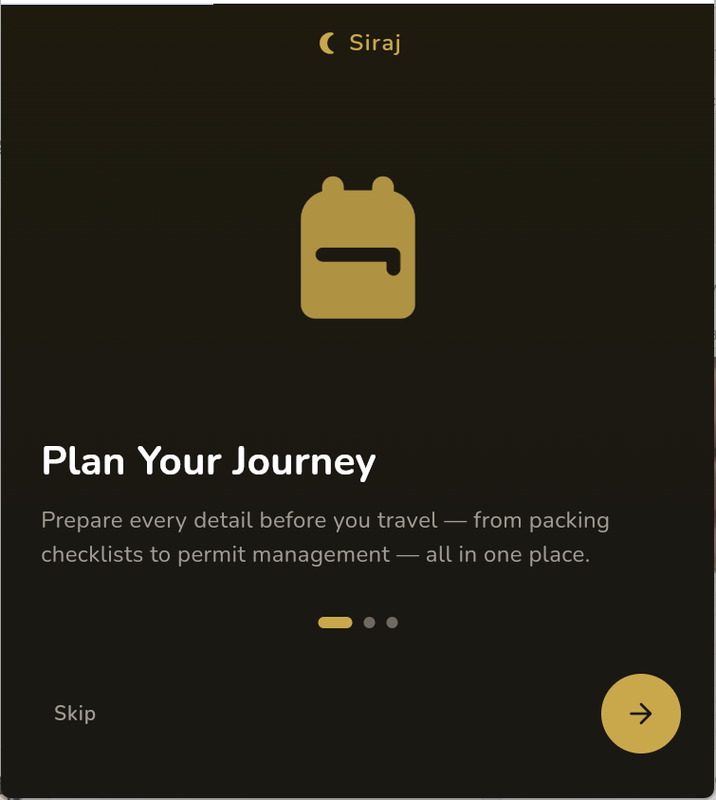
Figure 32 OnBoarding Screen
Figure A.1: Onboarding Slide 1 — Plan Your Journey
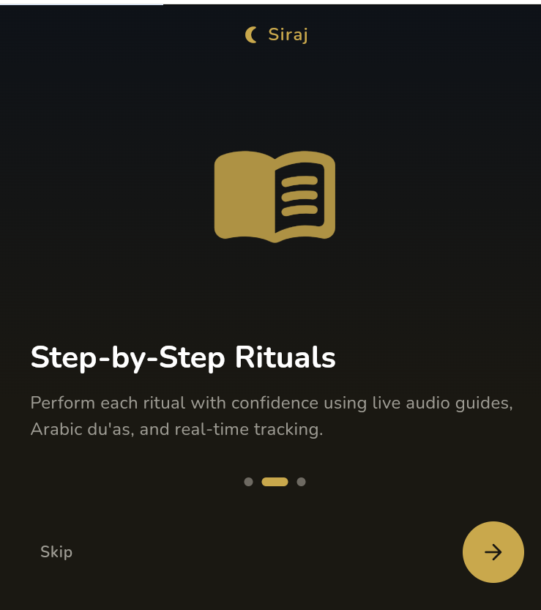
Figure 33 Onboarding Screen 2
Figure A.2: Onboarding Slide 2 — Step-by-Step Rituals

Tap the arrow to go through the slides, or tap Skip to go directly to the sign up/sign in options. If you are new, tap Sign Up. If you already have an account, tap Sign In.

A.2 Creating an Account
On the Sign Up screen, enter your full name, email address, and a password (at least 6 characters). After tapping Sign Up, you will be taken to a Profile Setup screen where you tell the app about yourself — are you a first-timer or experienced? Travelling alone, with family, or in a group? After completing this, you will be taken to the Home Dashboard.

A.3 Home Dashboard
The Home Dashboard shows a countdown to your journey, a grid of Quick Actions (Education Hub, Ritual Guide, Family Tracker, Emergency), and your packing checklist progress. Use the bottom navigation bar to switch between Home, Permits, Services, and Profile.

A.4 Ritual Guide
From the Home screen, tap Ritual Guide. You will see steps for Niyyah, Ihram, Tawaf, Sa'i, and Halq/Taqsir. Each step shows the Arabic text, transliteration, English translation, and instructions. Tap Next to go to the next step. There is also a separate Sa'i Guide in the Services tab that has a circuit counter from 0 to 7.

A.5 Services
The Services tab has: Select Your Stay (browse hotels), Select Transportation, Packing Checklist, Sa'i Guide, Emergency Assistance, and Finalize Journey. Tap any option to open it.

A.6 Permits
The Permits tab shows your digital travel permits fetched from the server. If no permits are found, you will see an option to open the Nusuk Portal to check your registration. Tap the refresh icon at the top to reload.

A.7 Emergency
To access emergency help, go to Services → Emergency Assistance. You will see a big red SOS button (hold for 2 seconds to call 911), all Saudi emergency numbers with a call button, nearby hospitals with distances, and embassy contact information.

A.8 Profile
The Profile tab shows your account settings — experience level, group type, language, and app preferences like prayer time alerts. Tap the edit icon at the top right to update your details.

Appendix B: Administrator Manual

B.1 Accessing the Admin Panel
The admin panel is available at the route /admin-login. Open the app and navigate to this route. Enter the admin email and password set up in Firebase Authentication. The admin panel has its own login and bypasses the normal user flow.


Figure 34 Admin Dashboard
Figure B.1: Admin Dashboard

B.2 Adding a Hotel
From the Admin Dashboard, tap "Add Hotel". Fill in the hotel name, city/location, distance from the Haram in km, price per night in SAR, rating (1–5), review count, amenities (comma-separated), optional image URL, and optional description. Tap Save to add it to Firestore. It will immediately appear in the pilgrim's hotel listing.


Figure 35 Adding Hotels
Figure B.2: Add Hotel Form

B.3 Editing or Deleting a Hotel
Tap "View Hotels" to see all current listings. Tap any hotel to edit its details. Use the delete option to permanently remove it. Changes go live immediately.

B.4 Tips for Admins
- Always double-check hotel distance from Masjid Al-Haram before saving
- Use high-quality image URLs (at least 600px wide) for best display
- Set all prices in Saudi Riyals (SAR)
- Update listings at the start of each Umrah season

Appendix C: Information / Promotional Material

C.1 App Overview
Umrah Ease is a mobile app that helps Muslims plan and perform their Umrah pilgrimage easily. Whether you are doing Umrah for the first time or the tenth time, the app has something useful for you.

Key features:
- Step-by-step Tawaf and Sa'i guide with Arabic duas
- Hotel booking with real prices and ratings
- Digital permit wallet
- Comprehensive Umrah training content
- Family safety tracking
- Emergency assistance with one-tap SOS
- Smart packing checklist

Built with Flutter and Firebase. Works on Android and iOS. Core features like the ritual guide and checklist work even without internet.

References and Bibliography
- Flutter Team. (2024). Flutter Documentation. Google LLC. https://flutter.dev/docs
- Firebase Team. (2024). Firebase Documentation. Google LLC. https://firebase.google.com/docs
- Riverpod Team. (2024). Riverpod State Management Docs. https://riverpod.dev
- GoRouter. (2024). go_router 14.x Package. pub.dev. https://pub.dev/packages/go_router
- sqflite. (2024). SQLite plugin for Flutter. https://pub.dev/packages/sqflite
- IEEE Computer Society. (1998). IEEE Standard 830-1998 for SRS. IEEE Press.
- Sommerville, I. (2016). Software Engineering (10th ed.). Pearson.
- Pressman, R. S. & Maxim, B. R. (2019). Software Engineering: A Practitioner's Approach (9th ed.). McGraw-Hill.
- Ministry of Hajj and Umrah, KSA. (2024). Official Umrah Guidelines. https://www.moh.gov.sa
- Dart Language Team. (2024). Dart Programming Language Docs. https://dart.dev/guides

